**PARAMOUNT INTEGRATED SCIENCE - NOTES**

**PRIMARY SIX**

**TERM ONE**

**THEME: THE WORLD OF LIVING THINGS**

**TOPIC: CLASSIFICATION OF LIVING THINGS**

* This is the grouping of living things according to their characteristics and features.

**Living things**

* These are things that have life.

**Examples of living things**

* Bean plant
* Maize plant
* Orange plant
* Pomegranate plant
* Cow
* Pig
* Goat
* Sheep
* Lion
* Zebra
* Horse
* Donkey
* Hen
* Duck
* Turkey
* Kite
* Hawk
* Owl
* Egret
* Bee
* Butterfly
* Tick
* Mite

**Characteristics of living things**

* They feed
* They reproduce
* They excrete
* They respond to their stimuli
* They respire
* They grow
* They move (locomote)
* They breathe

**Growth**

* This is the increase in size of organism.

**Reproduction**

* This is the process by which living things multiply

It prevents extinction of living things

It increases the population of living things

**Movement**

* Living things move to different places for some reasons.

All locomotions are movements but all movements are not locomotions

**Why do animals move (locomote) from one place to another?**

* To look for food
* To look for shelter
* To run away from their enemies (to escape danger)
* To look for mates
* To look for their friends
* To look for their young ones.

**How do animals move from one place to another? (Forms of locomotion)**

* By swimming
* By walking
* By flying
* By jumping
* By leaping (hopping)
* By crawling
* By slithering (gliding)
* By wriggling

**Excretion**

* This is the removal of metabolic waste products from the body.

It prevents body poisoning

**Respiration**

* This is the oxidation of food (glucose) in the body cells to produce energy.

It provides energy

**Name the two types of respiration**

* Aerobic respiration
* Anaerobic respiration

**Sensitivity**

* This is the ability of an organism to respond to external stimuli

It enables living things to detect danger

A **stimulus** is any change in the environment that causes an organism to react.

**Examples of external stimuli**

**For plants**

* Touch
* Light
* Gravity
* Water
* Chemicals

**For animals**

* Heat
* Pain
* Cold
* Smell

**FEEDING**

* This is the act of taking food into the body

**Why do living things feed?**

* To replace the worn out cells
* To be healthy
* To get energy
* To grow
* To stay alive

**Modes of nutrition in living things**

|  |  |
| --- | --- |
| **Living things** | **Modes (type) of nutrition** |
| Plants | Autotrophic nutrition |
| Animals | Heterotrophic nutrition |

**Modes of heterotrophic nutrition**

* Parasitic e.g in leeches, ticks, lice, mites, tapeworms and hookworms
* Saprophytic e.g in mushrooms, toadstools, yeast, moulds and puffballs
* Holozoic e.g in human beings, dogs and cats

**Reasons for classification of living things (Why do we classify living things?)**

* For easy identification
* For easy naming
* For easy study
* For conservation

**Features and characteristics used to classify living things**

* Body symmetry
* Body colour
* Body size
* Body shape
* Body divisions
* Number of legs
* Form of reproduction
* Type of respiration
* Mode of movement
* Mode of feeding
* Adaptation to the environment

**KINGDOMS OF LIVING THINGS**

* Kingdom Animalia (animal kingdom)
* Kingdom Plantae (plant kingdom)
* Kingdom Monera
* Kingdom Protista
* Kingdom Fungi

**GROUPS OF LIVING THINGS**

* Animals
* Plants
* Bacteria
* Fungi
* Protista

**DIFFERENCES BETWEEN PLANTS AND ANIMALS**

* Plants make their own food ( are autotrophs) while animals feed on already made food (are heterotrophs)
* Plants have chlorophyll while animals do not have chlorophyll
* Plants respond slowly to stimuli while animals respond quickly to stimuli
* Most plants are fixed in one place while most animals can move from one place to another freely
* Plants do not have sense organs while animals have sense organs
* Growth in plants occurs throughout life while growth in animals stops before their death.
* Plant cells have cell walls while animal cells have cell membrane

**ANIMALS**

These are multicellular organisms that are mobile, have no chlorophyll and have cells with cell membranes.

* A multicellular organism is an organism with many cells

**GROUPS OF ANIMALS**

* Vertebrates
* Invertebrates

**VERTEBRATES**

* These are animals with a backbone (spine or vertebral column)

**Importance of a backbone**

* It protects the spinal cord

**Functions of a spinal cord**

* It controls reflex actions
* It connects all nerves to the brain

**Characteristics of vertebrates**

* They have a backbone
* They have endoskeleton
* They have waterproof skin
* They have alimentary canal
* They have bilateral symmetry
* They have large brain protected by the skull
* Their backbone is made up of many small bones called **vertebrae**
* They have closed circulatory system

**Groups of vertebrates**

* Fish
* Amphibians
* Reptiles
* Mammals
* Birds

**Mention the two main classes of vertebrates**

* Warm blooded (homoeothermic or endothermic animals)
* Cold blooded (poikilothermic or ectothermic animals)

**A FLOW CHART SHOWING CLASSIFICATION OF VERTEBRATES**

**WARM-BLOODED VERTEBRATES (HOMEOTERMIC ANIMALS)**

* These are animals that maintain a constant body temperature

**Groups of warm-blooded vertebrates**

* Mammals
* Birds

**Examples of warm-blooded vertebrates**

* Parrot
* Duck
* Emu
* Turkey
* Pigeon
* Goat
* Dog
* Cow
* Cat

**COLD-BLOODED VERTEBRATES (POIKILOTHERMIC ANIMALS)**

* These are animals which do not maintain a constant body temperature
* These are animals whose body temperature changes with the surroundings

**Groups of cold-blooded animals**

* Fish
* Reptiles
* Amphibians

**Examples of cold-blooded vertebrates**

* Tilapia
* Mudfish
* Nile perch
* Chameleon
* Gecko
* Common lizard
* Crocodile
* Turtle
* Green snake
* Frog
* Toad
* Newt

**BIRDS**

These are vertebrates with feathers on their bodies

**Characteristics of birds**

* They have feathers
* They have beaks
* They have wings
* They have streamlined bodies
* They reproduce by laying eggs
* They undergo internal fertilization
* They have scales on their legs
* They are warm blooded animals
* They have a backbone
* They breathe by means of lungs
* They have three eyelids (the lower, upper and nictitating membrane)
* They care for their young

**EXTERNAL FEATURES OF A BIRD**

**Eyes**

* For sight

**Beak**

* For feeding
* For protection

**Legs**

* For walking

**Wattle and comb**

* For temperature regulation

**Nostril**

* For smelling

**ADAPTATIONS OF BIRDS TO FLIGHT**

* They have a streamlined body

To reduce air resistance/viscosity/friction in air

* They have hollow bones

To reduce body weight

* They have many quill (flight)feathers

For flight

* They have strong wings

To support the bird in air

To propel the bird forwards

* They have large pectoral muscles

To move the wings

* They have a keel on their breast bone

For attachment of pectoral muscles

* They have no pinna that would obstruct wind
* They have air sacs attached to the lungs

To improve gaseous exchange

* They have nictitating membrane on their eyes

To protect the eyes from wind

* They have a high metabolic rate

To provide the high amount of energy needed

* They have a keen eye sight

To judge distances correctly.

* They have a quick digestive system

**REASONS WHY SOME BIRDS ARE UNABLE TO FLY**

* They have heavy bones with bone marrow
* They have weak and small wings
* They have few flight feathers.
* They have no keel on their breast bone

**MOULTING IN BIRDS**

* This is the process by which birds shed damaged feathers.

Birds moult once each year

**Why do birds moult their feathers?**

* To replace damaged feathers (to grow new feathers)

**FEATHERS**

These are the outermost covers of the bird’s body

**Uses of feathers to a bird**

* They help a bird to fly (for flight)
* They streamline the body of a bird (they give the bird shape)
* They keep the bird’s body warm (for warmth)
* They protect the bird’s body from injury (for protection against injury)
* They help a male to attract mates (for courtship)
* They give the bird colour for identification

**Uses of feathers to people**

* They are used as costumes
* They are used for decoration
* They are used to make pillows
* They are used to make mattresses
* They are used as writing materials

**TYPES OF FEATHERS**

* Quill (flight) feathers
* Covert (body) feathers
* Down feathers
* Filoplume feathers

**QUILL FEATHERS (FLIGHT FEATHERS)**

They are found on the **wings** and **tail.**

They are divided into **primary** and **secondary feathers**

Primary feathers are bigger than secondary feathers

**Importance of quill feathers**

* For flight (they help in flying)

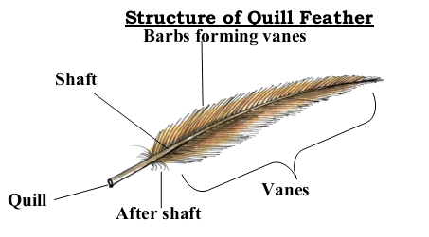

**Shaft (rachis)**

* It holds the vane (it is where the vane is attached)

**COVERT FEATHERS (BODY FEATHERS)**

* They are found on **the neck** and **bases of wings and tail**
* They cover most of the body
* 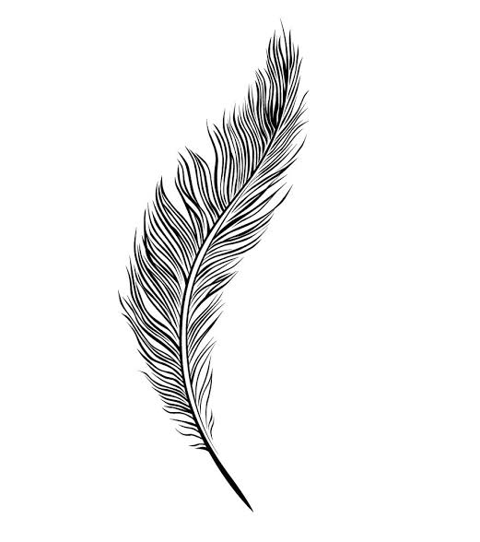They are smaller than the quill feathers

**Importance of covert feathers**

* They insulate the bird’s body
* They streamline the bird’s shape (they give the bird shape)

**Structure of a body feather**

**Why are bird streamlined?**

* To overcome viscosity (to reduce air resistance)

**What is viscosity (fluid friction)?**

* This is the friction in liquids and gases

**DOWN FEATHERS**

* They are found on the **abdominal region**
* They are the first feathers to appear on a bird
* They have no vane
* They have loose barbs

**Importance of down feathers**

* They insulate the bird’s body

**Structure of a down feather**

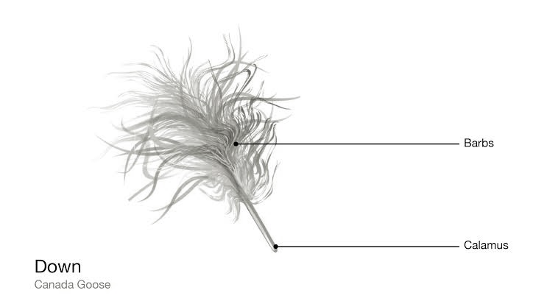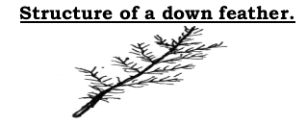

**FILOPLUME FEATHERS**

* These are the feathers that remain when a bird has been plucked
* They are found nearest to the skin between the covert feathers
* They are the tiniest (smallest) feathers
* They have no quill

**A drawing of a Filoplume feather**

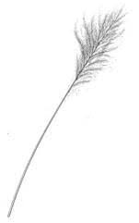

**REPRODUCTION IN BIRDS**

* They reproduce by laying eggs (they are oviparous )
* Their eggs are fertilized internally
* Birds undergo **internal fertilization**
* Fertilization in birds occurs in the **oviducts**

**STRUCTURE OF A FERTILIZED EGG OF A BIRD**

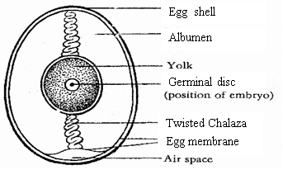

**FUNCTIONS OF EACH PART OF A FERTILIZED BIRD’S EGG**

**Egg shell**

* It protects the inner parts of an egg
* It allows exchange of gases

**How is the egg shell adapted to gaseous exchange?**

* It is porous

**How is the egg shell adapted to protection of the inner parts of an egg?**

* It is hard

**Why should layers be given mash (feeds) rich in calcium?**

* To lay hard shelled eggs

**Air space**

* It keeps oxygen for the embryo

**Egg yolk**

* It provides fats and proteins to the embryo

**Albumen (egg white)**

* It provides water and proteins to the embryo

**Chalaza**

* It holds the yolk and embryo in position
* It is the passage of oxygen to the embryo
* It is the passage of wastes from the embryo

**Germinal disc**

It is found in unfertilized egg

* It develops into an embryo after fertilization

**Embryo**

It is found in a fertilized egg

* It develops into a young bird

**Functions of an egg to the embryo**

* It protects the embryo
* It provides food to the embryo

**Abnormalities in bird’s eggs**

* Blood stained eggs
* Soft shelled eggs
* Double yolked eggs
* Yolkless eggs

**FEEDING IN BIRDS**

* Birds have no teeth
* They have horny beaks (bills)
* The shapes of beaks indicates the bird’s general diet

**DIGESTIVE SYSTEM OF A BIRD (HEN)**

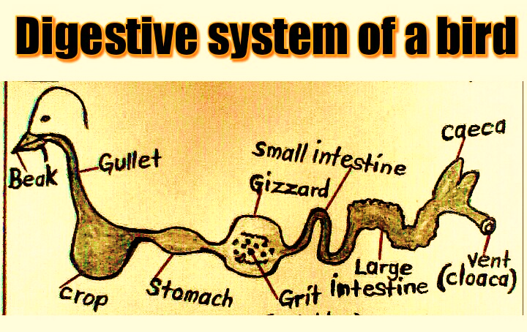

**FUNCTIONS OF EACH PART OF THE DIGESTIVE SYSTEM OF A BIRD**

**Beak (bill)**

* It picks food

**Gullet (oesophagus)**

* It passes food to the crop

**Crop**

* It stores food for a short time (for temporary storage of food)
* It moistens food
* It softens food
* It produces crop milk to feed the chicks e.g in pigeons

**Things that happen to food while in the crop of the bird**

* Food is moistened
* Food is softened

**Examples of birds that do not have a crop**

* Owl
* Goose
* Buttonquail

**Stomach (proventriculus)**

* It is where food is mixed with digestive juices
* It secretes digestive enzymes that begin the digestion of proteins

**Gizzard**

* It crushes (grinds) food

**How is the gizzard adapted to its function?**

* It has grit (small stones)

**How is the gizzard able to withstand the grit?**

* It has thick (muscular) walls

**Which part of the human digestive system perform the same function as the gizzard of a bird?**

* Teeth

**Grit**

These are small stones found in the gizzard of birds

* They crush food into small particles

**Small intestines (ileum)**

* It is where food digestion ends
* It is where food absorption occurs (it absorbs digested food)

**Main processes that take place in small intestines**

* Food absorption
* Food digestion

**Large intestines**

* It is where water absorption occurs (it absorbs water)

**Caecum**

* It stores undigested food for a short time

**Vent (cloaca)**

* It passes out droppings

**FACTORS CONSIDERED WHEN GROUPING BIRDS**

* Way of feeding
* Type of beak
* Type of foot
* Type of food they eat.
* Way of movement

**GROUPS OF BIRDS**

* Birds of prey (preying birds or raptors)
* Perching birds
* Scratching birds
* Swimming birds
* Wading birds
* Flightless (walking) birds
* Climbing birds
* Scavenger birds

**BIRDS OF PREY (RAPTORS)**

* These are birds that hunt and kill their prey.

**A prey** is an organism which is eaten by another organism

**Characteristics of preying birds**

* They have strong eye sight.

To spot their prey from long distances

* They have strong sharp hooked beaks

For tearing their prey (flesh)

* They have strong sharp curved (hooked) claws or talons

For gripping and killing their prey

**Examples of preying birds**

* Hawks
* Eagles
* Secretary birds
* Owls
* Kites
* Falcons
* Osprey
* Buzzard
* Harrier

**An eagle** is termed as the king of all birds.

**An owl**

* It is a nocturnal bird of prey
* It has no crop

**Why is an owl able to see at night?**

* It has more rod cells than cone cells in its eyes

**Food for preying birds (raptors)**

* Rats
* Fish
* Mice
* Geckos
* Chicks
* Smaller birds

**Diagram showing beak and foot of a preying bird**

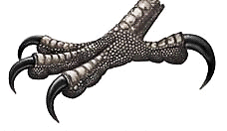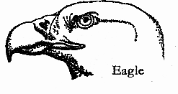

**How are birds of prey (raptors) dangerous to poultry farmers?**

* They eat chicks (they kill poultry)

**SCAVENGER BIRDS**

* These are birds that feed on carrion (leftover meat/carcasses/abandoned meat)

**How are scavenger birds important in the environment?**

* They clean the environment by eating carrion (dead animals)
* They prevent diarrhoeal diseases by eating rotten meat

**How do scavengers clean the environment?**

* By feeding on carrion (dead animals)

**Examples of scavengers**

* Vulture (condor)
* Crows
* Marabou stork

A marabou stork has long pointed heavy beak and long legs

**A drawing showing a marabou stork**

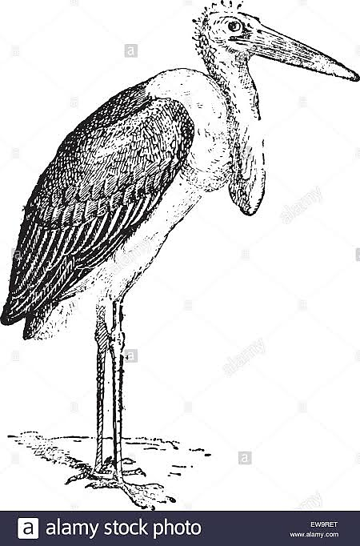

**Places where scavenger birds are commonly found**

* Dustbins
* Abattoirs
* Rubbish heaps

**Explain the meaning of the term carrion**

* This is the dead, decaying meat

**Of what importance is the pouch on the neck of a marabou stork?**

* It is used during courtship

**Name one scavenging bird of prey**

* Vulture

**CLIMBING BIRDS**

These are birds that climb trees.

**Examples of climbing birds**

* Parrot
* Woodpecker

**Characteristics of climbing birds**

* They have two toes facing forward and two backward

For climbing trees

* They have long stiff tails

For support when climbing upwards

* They have long toes with claws

For holding trees

* They live in trees
* A parrot has strong short hooked beak

For cracking hard seeds (nuts)

For climbing trees

* A parrot has a small space between the upper and lower beak

To hold seeds

* A woodpecker has chisel-shaped beak

For making holes in trees (for pecking wood)

**Why does a woodpecker peck trees?**

* To make nesting sites
* To look for food (insects)

**Why does a woodpecker drum on trees?**

* To attract mates
* To communicate to other woodpeckers
* To chase away predators

**Food for climbing birds**

* Insects
* Seeds

**Illustrations showing a beak of a parrot and a woodpecker**

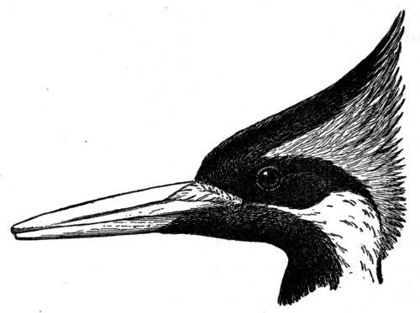

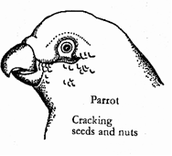

**Illustrations showing a foot of climbing birds (parrot and woodpecker)**

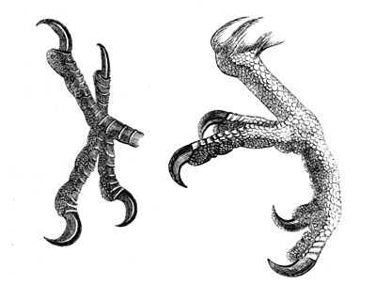

Parrot

Woodpecker

**SWIMMING BIRDS**

These are birds that have fully webbed feet for swimming in water.

**Characteristics of swimming birds**

* They have fully webbed feet

For swimming (paddling in water)

* They have broad breastbone.
* They have many oil glands in their skins

To produce oil that protects the bird from cold water.

To produce oil that makes the feathers waterproof

* They have a spoon shaped beak (have a beak with small cross plates on the margins)

To strain (sieve) food from water

**Examples of swimming birds**

* Ducks
* Swans
* Geese
* Penguins
* Seagulls
* Pelicans
* Cormorant

**Food for swimming birds**

* Tadpoles
* Worms
* Pond weeds
* Insects
* Small fish

**Structure of a foot and beak of a swimming bird**

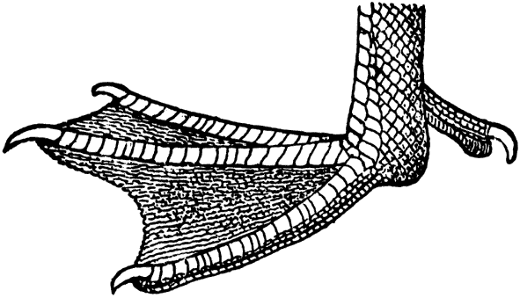

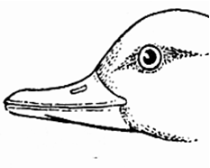

**WADING BIRDS**

* These are birds that can walk through water

These birds live near water bodies to get food easily

**Characteristics of wading birds**

* They have long flexible necks

To reach food below water surface

* They have thin long legs with half webbed feet

To prevent the bird from sinking in water

* They have long thin beaks

To catch food in water

**How are the thin long legs with half webbed widely spread toes useful to a wading bird?**

* They prevent the bird from sinking in water

**Examples of wading birds**

* Heron
* Flamingo
* Crested crane (crane)
* Marabou stork (stork)
* Sandpiper
* Ibis
* Egret
* Kingfisher
* Plover
* Jacana
* Spoonbill

**How are white egrets important to cattle farmers?**

* They eat up ticks on their cattle

**Food for wading birds**

* Fish
* Frogs
* Worms

**Structure of a beak and foot of heron**

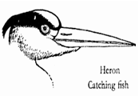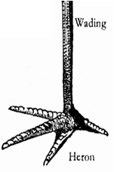

**FLIGHTLESS BIRDS (WALKING BIRDS)**

These are birds that cannot fly

**Characteristics of flightless birds**

* They have small weak wings.
* They have heavy bones with bone marrows
* They run very fast

**Examples of flightless birds**

* Kiwi
* Ostrich

Ratites

* Emu
* Rhea
* Cassowary
* Penguin

**Kiwi**

It is the only bird with a nostril at the end of its beak

**Ostrich**

* It is the largest and fastest flightless bird.
* It can run faster than most **horses**.
* It can run at an average speed of 45 miles per hour
* It is the only bird with two toes on each foot

**Illustrations showing a kiwi and an ostrich**

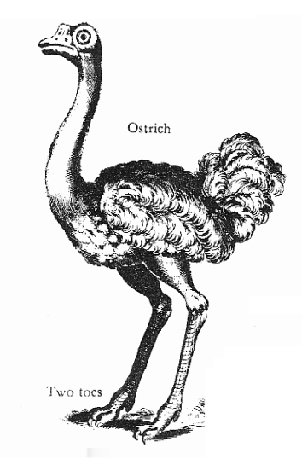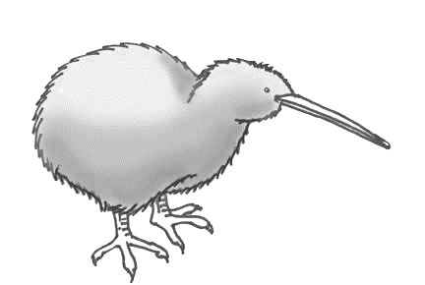

**Drawings showing feet of flightless birds** 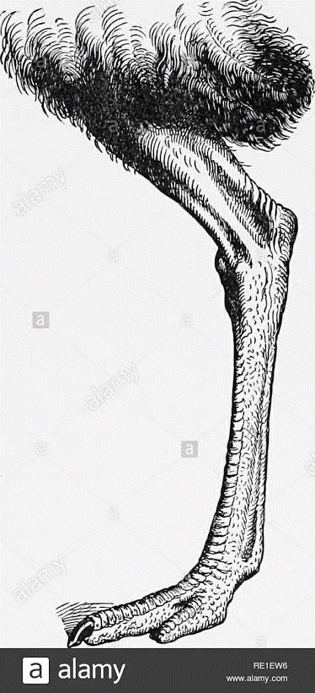

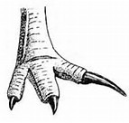

Emu, cassowary, rhea and kiwi

Ostrich

**Food for flightless birds**

* Worms
* Insects
* Small animals

**How do some flightless birds (ostrich, emu and cassowary) protect themselves?**

* By kicking with their strong huge legs

**Give a reason why some domestic fowls are unable to fly high**

* They have heavy bones with bone marrow

**PERCHING BIRDS (SONG BIRDS/PASSERINES)**

These are birds that can roost (rest) on branches of trees.

**A perch** is a piece of wood on which a bird sleeps (rests)

**Characteristics of perching birds**

* They have split feet and walking legs.
* They have three toes pointing forwards and one pointing backward

For gripping the perches

* They have strong toes to grip on the trees.

**A drawing showing foot of perching birds**

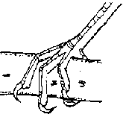

**Groups of perching birds**

Perching birds are grouped according to their feeding habits

* Seed eaters
* Nectar suckers
* Insect eaters
* Fruit eaters

**Seed eaters**

These are perching birds that feed on seeds.

* They have strong short conical beaks;

For breaking up seeds

**Examples of seed eaters**

* Pigeon
* Dove
* Weaverbird
* Finch

**A drawing showing a beak of a seed eater (e.g dove)**

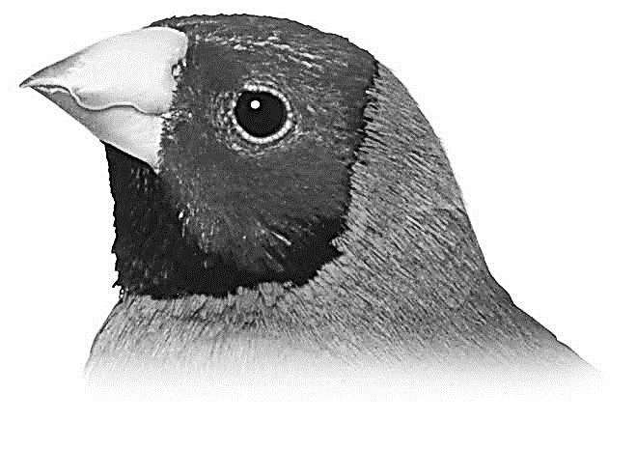

**Insect eaters**

These are perching birds that feed on insects.

* They have short narrow beaks;

For picking up insects from tree barks

**Examples of insect eaters**

* Swifts
* Shrikes
* Swallows
* Nightjars
* Sparrows
* Robins
* Woodcreepers
* Bee-eaters

**A drawing showing an insect eater (e.g robin)**

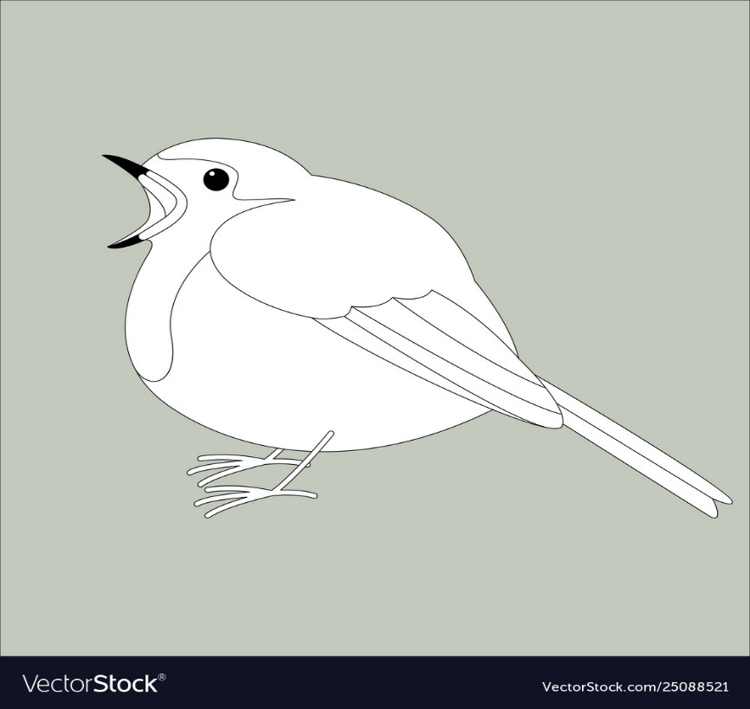

**Why do swifts and swallows** have short and wide open beaks?

* To catch insects while flying

**A drawing showing a beaks of insect eaters (e.g swift)**

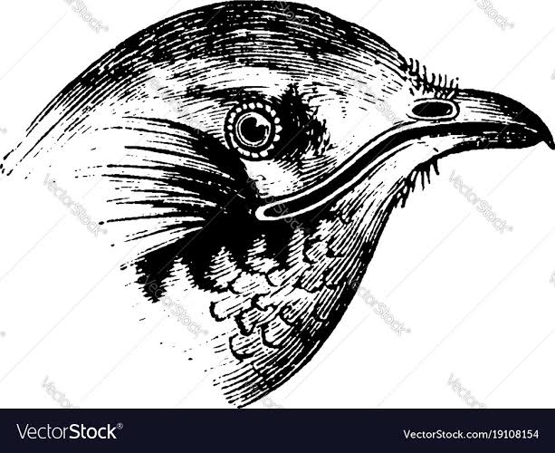

**Why shrikes are sometimes called butcher birds?**

* They spear insects on thorns to eat it later

**Nectar suckers (honey eaters)**

These are perching birds that feed on nectar from flowers.

* They have long slender curved beaks;

For sucking nectar from flowers

**Examples of nectar suckers**

* Sunbird
* Hummingbird

**A beak and foot of a sunbird**

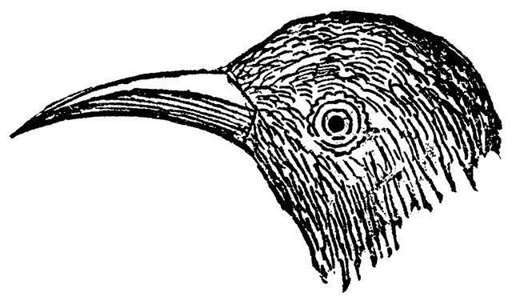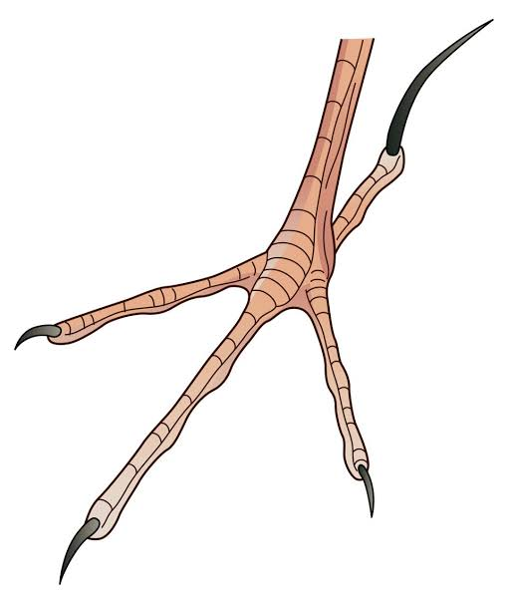

**Fruit eaters (frugivores)**

These are perching birds that feed on fruits from trees.

* They have long down curved beaks;

For collecting fruits from trees

**Examples of fruit eater**

* Hornbill
* Toucan

They help in fruit and seed dispersal

**A drawing showing a beak of hornbill**

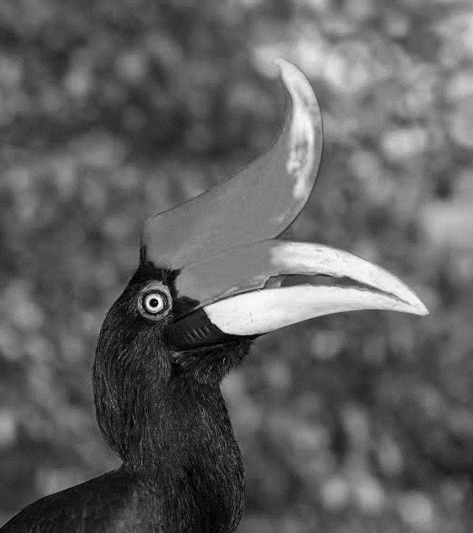

**SCRATCHING BIRDS**

These are birds which scratch the ground for food.

**Characteristics of scratching birds**

* They have strong feet with blunt claws.

For scratching

* They have strong feet with blunt claws.

For scratching

* They have strong short pointed beaks

For picking up food from soil

**Examples of scratching birds**

* Chickens
* Turkeys
* Guinea fowls
* Pheasants
* Crested francolin

**Food for scratching birds**

* Seeds
* Insects

**Structure of the beak and foot scratching bird**

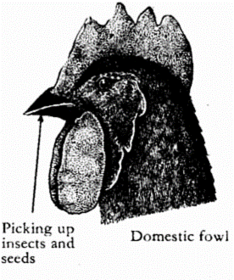

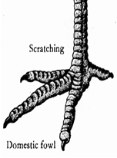

**IMPORTANCE OF BIRDS IN THE ENVIRONMENT**

* Some birds are a source of meat
* Some birds are a source of eggs
* Some birds are a source of income when sold
* Some birds attract tourists e.g flamingo birds and ostriches
* Some birds pollinate flowers e.g sunbirds and hummingbirds
* Some birds help in seed dispersal
* Some birds are used as dowry
* Some birds are used as sacrifices
* Some birds help to clean the environment by feeding on rotten meat (carrion)
* Their droppings are used as manure
* Their bones are used for making glue
* Their feathers are used for decoration
* Their feathers are used to make costumes

**DISADVANTAGES (DANGERS) OF BIRDS**

* Some birds are crop pests e.g weaverbirds
* Some birds cause airplane accidents. (They lead to bad strikes)
* Some birds make a lot of noise e.g weaverbirds.
* Some birds hide parasite e.g fleas and mites
* Birds of prey kill poultry

**MAMMALS**

* These are animals with mammary glands

**Main characteristics of mammals**

* They have mammary glands
* They have hair (fur) on their bodies
* They have ossicles ( they have three middle ear bones)

**Other characteristics of mammals**

* They are warm blooded
* They breathe by means of lungs
* They have backbone
* They undergo internal fertilization
* They care for their young
* They have four chambered heart
* Most mammals give birth to live young ones (most of them are viviparous)
* Most mammals have well developed pinnae (ear lobe)

**State the importance of mammary glands to female mammals**

* To produce milk for feeding their young ones

**Importance of body hair/fur on mammals**

* It keeps the body warm (for temperature regulation)
* It protects the body from injury
* For sensing

**Groups of mammals**

* Primates (fingered mammals)
* Ungulates (hoofed mammals)
* Carnivorous mammals (flesh eating mammals)
* Gnawing mammals (rodents and lagomorphs)
* Insectivorous(insect eating mammals)
* Pouched mammals (marsupials)
* Flying mammals (chiroptera)
* Egg laying mammals (monotremes)
* Sea mammals (cetaceans and sirenians)

**PRIMATES (FINGERED MAMMALS)**

* These are mammals with well-developed brain

**Characteristics of primates**

* They have a well-developed brain
* They have 5 fingers on each hand and 5 toes on each foot.
* They are omnivores
* They have forward facing eyes
* They have four types of teeth (incisors, canines, premolars and molars)
* They have four limbs

Fore limbs for holding and hind limbs for walking.

**Why are primates regarded as the most advanced group of mammals?**

* They have well developed brain

**Why are mammals called omnivores?**

* They feed on both meat and vegetation

**Examples of primates**

* Human being

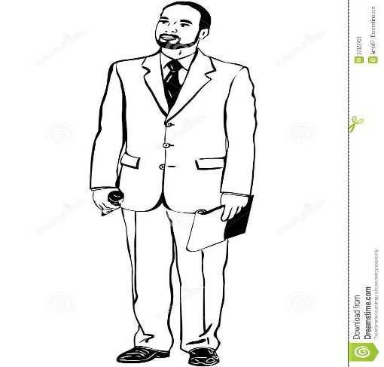

Human being

* Chimpanzee (bonobo)

Apes

* Gorilla
* Orangutan
* Gibbons
* Monkey
* Baboon
* Bushbaby

**What are apes?**

* These are primates with no tails

**DIAGRAMS SHOWING SOME PRIMATES**

|  |  |  |  |
| --- | --- | --- | --- |
|  |  |  |  |
| Gorilla | Orangutan | Monkey | Bushbaby |

**EGG LAYING MAMMALS (MONOTREMES)**

These are mammals that lay eggs

* They lay 1 to 3 eggs
* Monotremes have characteristics of birds, mammals and reptiles

**Reasons why monotremes are the most primitive in the class of mammals**

* They lay eggs
* They feed using a beak (bill)
* They have only one opening (cloaca) for reproduction and excretion

**Why are monotremes regarded as mammals?**

* They have hair on their bodies
* They have mammary glands (they produce milk for their young ones)
* They care for their young after hatching

**Examples of egg laying mammals (monotremes)**

* Duck billed platypus
* Spiny anteater (echidna)

**Diagrams showing monotremes**

Duck billed platypus

Spiny anteater (echidna)

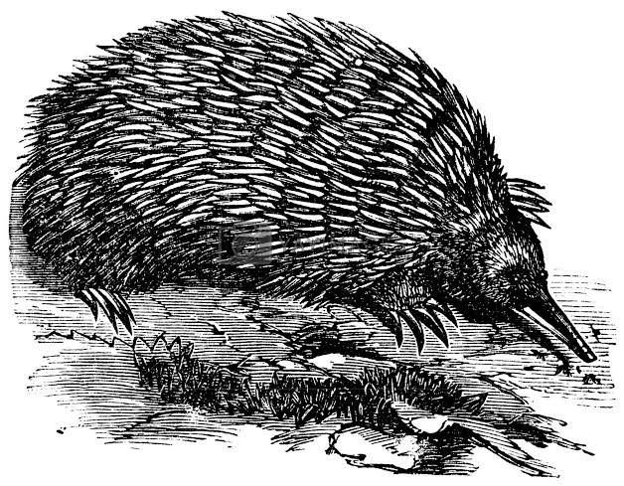

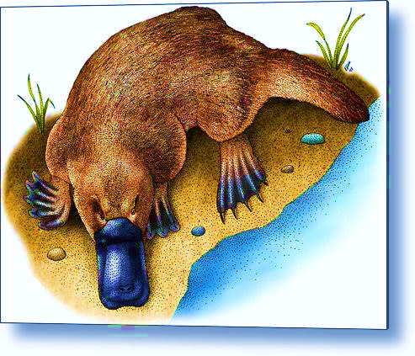

**How do monotremes locate their food?**

* By electroreception

**UNGULATES (HOOFED MAMMALS)**

These are mammals with hooves

* All ungulates are herbivores

**Groups of ungulates**

* Odd toed ungulates
* Even toed ungulates

**Odd toed ungulates**

These are ungulates with one or three toes on each foot

**Examples of odd toed ungulates**

* Horse

One toe on each foot

Three toes on each foot

* Donkey
* Zebra
* Elephant
* Rhino

**Drawings showing toes of odd toed ungulates**

**Horse Elephant**

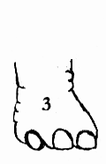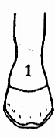

**Even toed ungulates**

These are ungulates with two toes on each foot

**Examples of even toed ungulates**

* Cattle
* Goat
* Sheep
* Antelope
* Giraffe
* Camel
* Okapis
* Deer
* Elk
* Pig
* Warthog
* Hippo

**Drawings showing toes of odd toed ungulates**

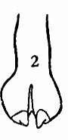 **Cow Camel**

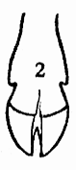

**Subgroups of even toed ungulates**

* Ruminants
* Nonruminants

**Ruminant animals**

These are animals that chew cud

* They have four stomach chambers

**Examples of ruminant animals**

* Cattle
* Goat
* Sheep
* Giraffe
* Camel
* Deer
* Antelope
* Elk

**How do most ruminants protect themselves?**

* By using their horns.

**Name the four stomach chambers of ruminant animals**

* Rumen
* Reticulum
* Omasum
* Abomasum

**A DIAGRAM SHOWING THE FOUR STOMACH CHAMBERS OF RUMINANTS**

**Gullet (oesophagus)**

* It passes food to the rumen

**Rumen**

It is the first and largest stomach chamber

* It stores food for a short time before rumination
* It ferments and softens food

**Reticulum**

It is the second stomach chamber

* It retains foreign bodies.

**Omasum**

It is the third stomach chamber

* It absorbs water

**Abomasum (true stomach)**

It is the fourth stomach chamber

* It mixes food with digestive enzymes

**Nonruminant animals**

* These are animals that do not chew cud

**Examples of nonruminant animals**

* Pig
* Hippo (hippopotamus)
* Warthog

Nonruminants have **well developed canines for protection**

**CARNIVOROUS MAMMALS (FLESH EATING MAMMALS)**

These are mammals that feed on flesh/meat

**Characteristics of carnivorous animals (adaptations of carnivorous mammals to hunting)**

* They have well developed canines

For tearing flesh (prey)

* They have strong sharp claws

For gripping and killing their prey

* They have very good speed
* They have good sense of smell, vision and hearing
* They have soft pads in their feet

To run after their prey silently

* They are strong animals

**An illustration showing a skull of a carnivorous mammal**

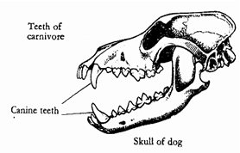

**Families (sub groups) of carnivorous mammals**

* Dog family
* Cat family

**DOG FAMILY**

These are dog-like carnivorous mammals

**Examples of carnivorous mammals under the dog family**

* Domestic dog
* Fox
* Jackal
* Wolf

**CAT FAMILY**

These are cat-like carnivorous mammals

They have retractile claws

**Examples of carnivorous mammals under cat family**

* Domestic cat
* Cheetah
* Lion
* Leopard
* Tiger
* Jaguar
* Mongoose
* Hyena
* Civet
* Puma/cougar/panther
* Lynx

**Cheetahs** can run as fast as 70 miles per hour (120kph)

**Drawings of domestic dog and cat**

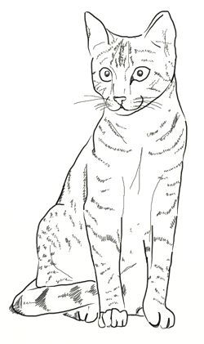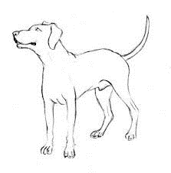

**NOTE**

* Most carnivorous mammals are **predators**
* **Predators** are animals that hunt and kill their prey
* Some carnivorous mammals are **scavengers**
* **Scavengers** are animals that feed on **carrion** (abandoned meat)

**Examples of scavenger mammals**

* Jackal
* Hyena
* Fox

**Importance of carnivorous mammals to man**

* Domestic dogs are used for hunting
* Domestic dogs are used for protection at home
* Domestic cats are used to kill rats at home
* Civets produce musk used in perfumes

**GNAWING MAMMALS**

These are mammals that chew rapidly

**Characteristics of gnawing mammals**

* They have well developed incisors
* They have no canines.

**Groups of gnawing mammals**

* Rodents
* Lagomorphs

**Rodents**

These are gnawing mammals with one pair of upper incisors

**Examples of rodents**

* Rat
* Squirrel
* Mouse
* Mole
* Porcupine
* Guinea pig
* Beavers
* Marmot
* Chipmunks
* Prairie dog
* Voles
* Lemming
* Muskrat
* Hamster

**Lagomorphs**

These are gnawing mammals with two pairs of upper incisors

**Examples of lagomorphs**

* Rabbits
* Hares
* Pikas

**Drawings showing rodents (rat and squirrel) and lagomorph (rabbit)**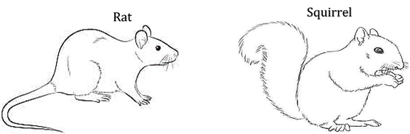

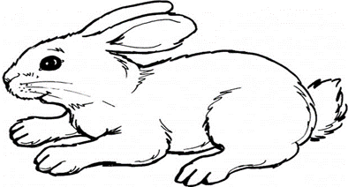

**Differences between lagomorphs and rodents**

* Lagomorphs have two pairs of upper incisors while rodents have one pair of upper incisors
* Lagomorphs are herbivores while rodents are omnivores
* Lagomorphs have short tails while rodents have long tails

**INSECT EATING MAMMALS (INSECTIVORES)**

* These are mammals which feed on insects.

**Characteristics of insect eating mammals**

* They have good sense of smell
* They are nocturnal (they are active at night)
* They live in burrows or trees
* They have sharp claws for digging out insects from soil
* They have long sensitive snouts
* They have abnormal appetite for food

**Examples of insect eating mammals**

* Hedgehog
* Elephant shrew
* Aardvark
* Aardwolf
* Golden mole
* Solenodon

**A drawing of a hedgehog**

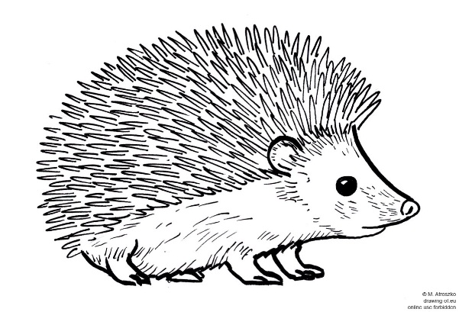

**How does a hedgehog protect itself?**

* It rolls into a spiny ball

**FLYING MAMMALS (CHIROPTERA)**

* These are mammals that can fly

**An example of a flying mammal**

* **Bats**

**A bat** is the only true flying mammal

**How is a bat adapted to flight?**

* Its fore limbs are modified into wings

**Why are bats called nocturnal animals?**

* They are active at night (they hunt at night)

**A drawing showing a bat**

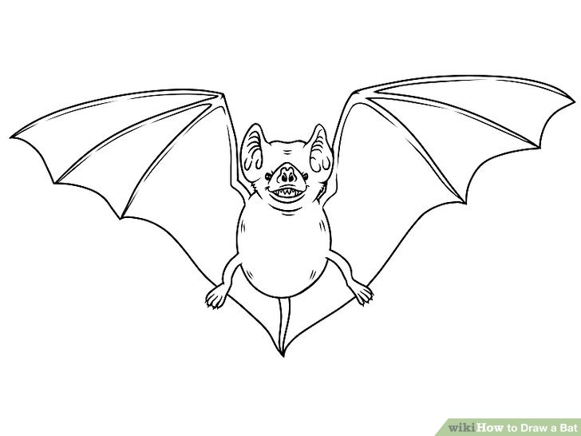

**Groups (types) of bats**

* Insectivorous bats (insect eating bats)
* Frugivorous bats (fruit eating bats)
* Blood-sucking bats (vampire bats)

**Insect eating bats (insectivorous bats)**

These are bats that feed on insects

**Fruit eating bats**

These are bats which feed on fruits

**Blood sucking bats/vampire bats**

These are bats that feed on blood

**Importance of bats in the environment**

* They feed on insect vectors e.g mosquitoes and flies
* They feed on insect pests
* They help in pollination
* They help in seed dispersal
* Their guano is used as fertilizers

**Dangers of bats**

* They hide parasites e.g fleas
* They are disease vectors (they spread histoplasmosis)
* They make a lot of noise
* Their dung causes bad smell in houses
* Vampire bats bite farm animals
* They destroy fruits on crops
* Vampire bats suck blood from farm animals e.g cattle

**How can crop farmers protect their bananas against fruit eating bats?**

* By early harvesting
* By using net traps

**Bats are blind, how are they able to locate food at night?**

* They use echoes

**How are echoes useful to bats?**

* They help bats to find food at night
* They help bats to find their way at night

**How?**

* By dodging obstacles

**POUCHED MAMMALS (MARSUPIALS)**

These are mammals with a pouch (marsupium) to carry its young one

The young one of a marsupial is **called** joey

**Examples of pouched mammals**

* Kangaroo
* Koala
* Wallaby
* 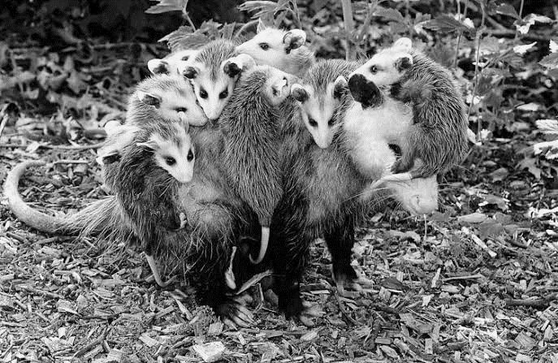Opossum

Opossum and its joeys

* Quokka
* Phalanger
* Dasyure
* Tasmanian devil
* Wombat
* Numbat
* Bandicoot

They are most common in **Australia** and some few in **America**

**Why does a kangaroo carry its joey in a pouch?**

* To feed its immature young (joey)

**How are marsupials different from other mammals?**

* They feed their immature young ones in a pouch/marsupium unlike other mammals

**A diagram showing a kangaroo**

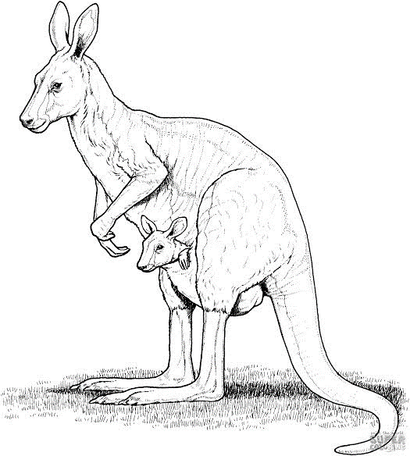

Kangaroo

A joey in a pouch

**MARINE MAMMALS**

* These are mammals that live in seas

They are also called **sea mammals** or **aquatic mammals**

**Characteristics of marine mammals**

* They have blubber
* They have streamlined bodies
* They have flippers for swimming
* They have well developed brain next to primates

**EXAMPLES OF SEA MAMMALS (MARINE MAMMALS)**

* Whales (blue and sperm whales)

Cetaceans

* Porpoise
* Dolphin
* Dugong
* Manatee
* Seal
* Sea lion
* Walrus
* Sea otter

**A blue whale** is the largest known living mammal

**How do sea mammals breathe?**

* By means of lungs

**Blubber**

This is a fatty layer under the skin of sea mammals

* It keeps them warm

**How is blubber useful to sea mammals?**

* It keeps the sea mammal warm in cold water

**How does blubber keep the sea mammals warm in water?**

* It prevents heat loss

**How is a sea mammal able to survive in cold seawater?**

* It has blubber

**Drawings showing cetaceans (dolphin and whale)**

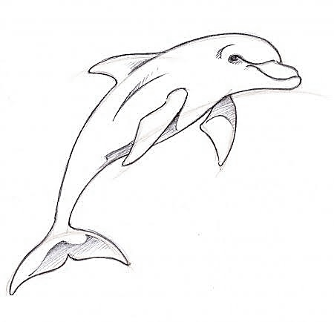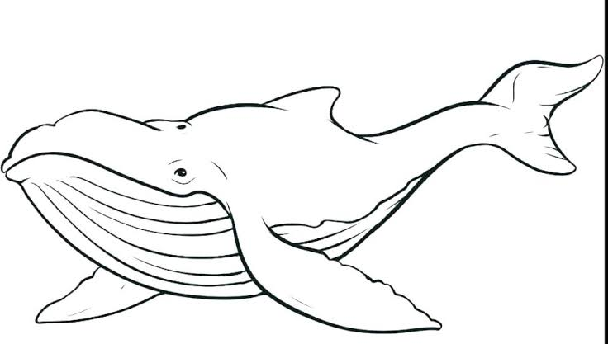

**MENTION THE THREE MAIN CLASSES OF MAMMALS**

* **Placental mammals**

These are mammals that give birth to fully grown young ones

* **Pouched mammals**

These are mammals that give birth to immature young ones and care for them inside their pouch

* **Monotremes**

These are mammals that reproduce by laying eggs

**IMPORTANCE OF MAMMALS**

* Some mammals are a source of food
* Some mammals are used for transport e.g horses
* Some mammals provide animal labour
* Some mammals attract tourists
* Some mammals guard our homes e.g dogs
* Some mammals are sold for money
* Some mammals provide skins to leather industries
* Some mammals eat disease vectors e.g bats
* Their wastes are used to make biogas and farmyard manure

**DISADVANTAGES OF MAMMALS**

* Some mammals are crop pests
* Some mammals kill people
* Some mammals are disease vectors e.g rabid dogs

**AMPHIBIANS**

These are cold blooded vertebrates that can live in water and on land

**Characteristics of amphibians**

* They can live in water and on land
* They are cold blooded/poikilothermic animals
* They reproduce by laying eggs
* They undergo external fertilization
* They have a backbone
* They have no external ears
* They breathe by means of lungs on land
* They have three chambered hearts
* They have scaleless skin/have no scales on their skins
* They lay their eggs in water
* They do not produce amniotic eggs
* They go through metamorphosis
* They spend their first life in water and later go on land

**NOTE**

* They have an eardrum under the skin on the head

**Examples of amphibians**

* Frogs
* Toads
* Newts
* Salamanders (axolotl)
* Caecilians

**Frogs and toads** have no tails

**Newts and salamanders** have tails

**Caecilians** have no limbs (they are limbless amphibians)

**A drawing of a newt and a salamander**

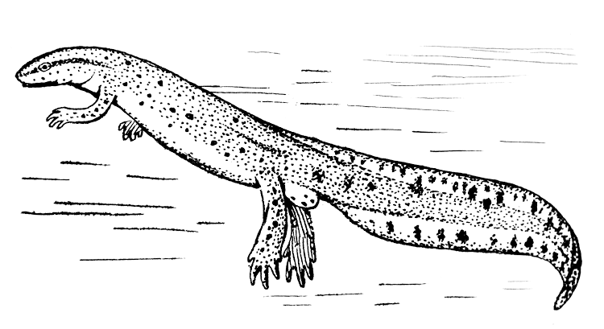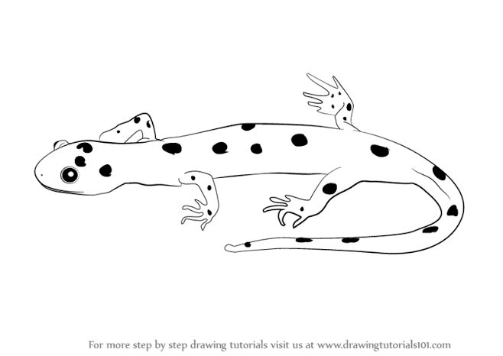

**Name the amphibian shown in the diagram below**

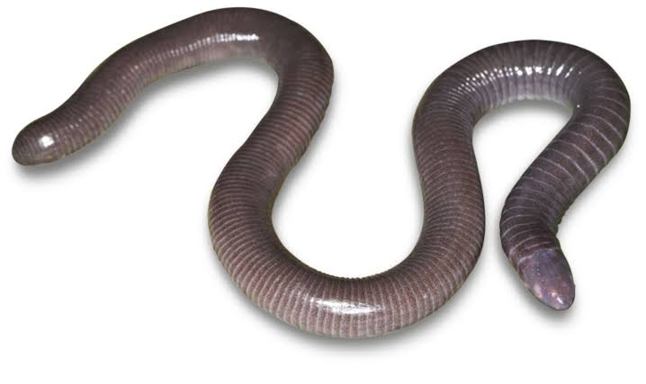

Caecilian

**External features of a toad**

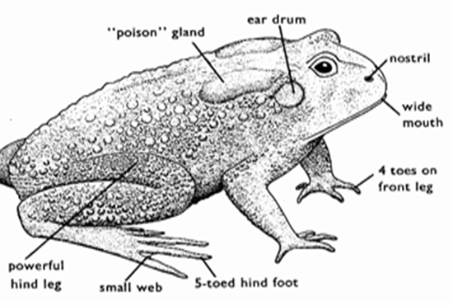

**Importance of each part of a toad**

* **Mouth**

For feeding

* **Nostril**

For smelling food

* **Eyes**

For sight

* **External eardrum**

For hearing

* **Poison gland/paratoid gland**

To produce poison keeps away predators

* **Strong hind legs**

For hopping/leaping

* **Webbed feet**

For swimming in water

**Differences between a frog and a toad**

* A frog lives in water while a toad lives on land.
* A frog has smooth skin while a toad has rough skin
* A frog lays eggs in clusters/bunch/big spawn while a toad lays eggs in strings/ribbon-like spawn
* A toad has poison/paratoid gland while a frog has no poison gland
* A frog has fully webbed hind feet while a toad has half webbed feet
* A frog can breathe through its skin while a toad cannot breathe through its skin
* A frog has teeth in upper jaw while a toad has no teeth
* A frog has brown tadpoles while a toad has black tadpoles

**EGGS OF FROGS AND TOADS**

Their eggs are called **spawn**

**Frog spawn Toad spawn**

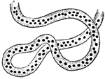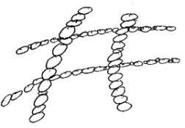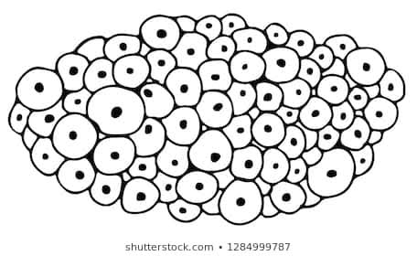

**Importance of jelly on eggs of frogs and toads (frogspawn and toadspawn)**

* It prevents eggs from drying up/it keeps the eggs moist
* It protects the eggs from predators
* It prevents bacterial infections
* It activates the sperms to fertilise the eggs

**How does the jelly protect eggs of amphibians from predators?**

* It has unpleasant taste
* It sticks the eggs together

**MOVEMENT IN AMPHIBIANS**

* Amphibians move in water **by swimming**
* Toads and frogs move on land by **leaping/hopping/jumping**
* Strong hind legs **help the frog or toad to leap/jump**
* Fore legs **absorb shock on landing**
* Webbed hind feet **help a frog or toad to swim in water**
* Newts and salamanders move **by walking**

**FEEDING IN FROGS AND TOADS**

* They are carnivorous animals
* They feed on worms and insects (e.g housefly, mosquito larva, cockroach and beetle)
* They have wide mouth and long sticky tongues

To trap their prey (insects)

* A frog has teeth in the upper jaw

To prevent the prey in mouth from escaping

* Tadpoles feed on water weeds and small water animals

**How do frogs in ponds help in control of malaria?**

* They eat mosquito larvae

**BREATHING IN TOADS AND FROGS**

**Frogs and toads can breathe through the following organs**

**Frog**

* Lungs
* Moist skin
* Buccal cavity (lining of mouth)

In water, a frog breathes **through its moist skin**

**How is a frog able to live in water and on land?**

* It can breathe through its moist skin in water and through the lungs on land

**Toad**

* Lungs
* Buccal cavity (lining of mouth)

**Why can a frog breathe through is skin?**

* Its skin is moist

**Why can’t a toad breathe through its skin?**

* Its skin is dry

**Tadpole**

This is the larva stage of a frog and toad

* Gills

**How do amphibians protect themselves?**

* Toads

By producing poison to kill small enemies, by swelling to scare away enemies

* Frog

By using their slippery skin to escape from enemies, by hiding in water, by swelling to scare away enemies, by camouflaging

**Diagram to show life cycle of a frog**

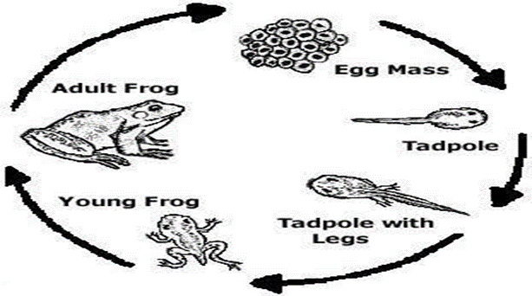

**Reproduction in frogs and toads**

* Breeding/mating/reproduction in frogs and toads occurs in **wet/rainy season**
* They reproduce by laying eggs
* The spawn (eggs of amphibians) are **fertilized externally**
* The eggs of amphibians are called **spawn**
* The lay their eggs in water (ponds and stagnant water)

To prevent the eggs from drying up (desiccation)

* The frogspawn and toadspawn are covered with **smelly jelly**
* The eggs hatch into larvae called **tadpoles**
* A tadpole has **gills** for breathing and a **tail** for swimming
* As a tadpole grows, it loses the gills and develops lungs
* Tadpoles later grow into adult frogs and toads.

**Why do amphibians lay very many eggs?**

* To prevent extinction of their species

**Why do male frogs and toads croak/make noise?**

* To attract females/mates

**How is sun’s heat important to spawn?**

* It enables the spawn to hatch

**Briefly explain how the eggs of amphibians are fertilized externally?**

* The male sheds sperms over the eggs after being laid

**Why are eggs of amphibians fertilized as they come out of the female?**

* To prevent the eggs from swelling before fertilization

**Toads live on land. Why do they sometimes go into water?**

* To lay eggs

**ADAPTATIONS OF A FROG TO ITS LIFE IN WATER**

* It has streamlined body to overcome friction in water
* It has webbed hind feet for swimming in water
* It has moist skin for breathing in water
* It has slippery body to escape enemies in water

**HIBERNATION AND AESTIVATION IN AMPHIBIANS**

* **Hibernation** is the inactive state in some animals during winter
* **Aestivation** is the inactive state in some animals during summer/hot weather

**During inactive/dormant periods:**

* Frogs hide in burrows and breathe through their moist skin
* They feed on fats and glycogen stored in their body.

**Why do amphibians aestivate/hibernate?**

* To prevent drying up
* To maintain body temperature
* To survive during harsh weather (e.g drought and winter)

**Differences between a tadpole and a frog**

* A tadpole breathes through gills but a frog breathes through moist skin, lungs and lining of mouth
* A tadpole swims by means of tail while a frog swims by means of webbed hind feet

**Importance of amphibians to people**

* They eat insect vectors e.g mosquitoes and cockroaches
* They eat insect pests
* They are used in science experiments
* Some amphibians are eaten by people

**REPTILES**

These are vertebrates that move by crawling and slithering

**Characteristics of reptiles**

* They have scales on their bodies
* They use lungs for breathing
* They are cold blooded animals
* They undergo internal fertilization
* They lay hard shelled eggs
* They have a backbone
* They have three chambered hearts
* They have waterproof skin
* Most reptiles have four limbs except snakes (they are tetrapods)
* They move by crawling and slithering
* Most reptiles reproduce by laying eggs
* Most reptiles are terrestrial animals (live on land) though some swim in water

**Examples of reptiles**

* Kingsnake
* Gaboon viper
* Mamba
* Chameleon
* Crocodile
* Tortoise
* Turtle
* Alligator
* Gecko
* Common lizard

**Groups (classes) of reptiles**

* Snakes
* Lizards
* Testudines (turtles and tortoises)
* Crocodilians (crocodiles and alligators)

**TORTOISES AND TURTLES**

* These are reptiles with hard bony shells

**Characteristics of tortoises and turtles**

* They have hard shells

To protect the animal from predators

To prevent the animal from drying up

* They have no teeth but have sharp jaws to tear food
* They breathe by means of lungs
* They lay their eggs in loose sand
* They have four limbs
* They have very long lifespan

Tortoises may live for 150 to 300 years

Turtles live for about 20 to 40 years

**Examples of turtles and tortoises**

* Tortoise
* Turtle
* Terrapin

Terrapins are turtles that live in fresh and salty water

**Drawings showing tortoise and terrapin**

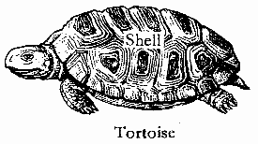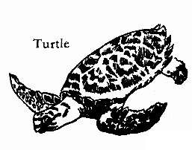

**What do we call the upper and lower shells of turtles and tortoises?**

* Upper shell is called **carapace**
* Lower shell is called **plastron**

**How do turtles and tortoises protect themselves?**

* By hiding in their hard shells

**Differences between turtles and tortoises**

* Tortoise has raised(dome shaped) shell while a turtle has flat shell
* Tortoise lives on land while turtle lives in water
* Tortoises have strong stumpy feet for walking while turtles have webbed feet (flippers) for swimming in water
* Tortoises are herbivores while turtles are omnivores

**Food for turtles and tortoises**

* Insects
* Small animals
* Vegetation

**SNAKES**

These are limbless reptiles

**Characteristics of snakes**

* They have no limbs/they are limbless
* They undergo moulting

To grow/to increase in size

* They move by slithering/gliding
* They are carnivorous animals/feed on flesh
* They have a forked tongue

For smelling

For tasting

* They have Jacobson's organ

For tracking their prey

* Their teeth point backward

To prevent the prey in mouth from escaping

* They have no external ears

**What is moulting?**

This is the shedding of outer layer of the skin in some animals

**Why do reptiles moult?**

* To grow (to increase in size)

**How do snakes detect movement?**

* By feeling vibration in the ground with their jawbone

**Why do snakes move while bringing out their forked tongue?**

* For smelling
* For tasting

**Food for snakes**

* Small insects
* Eggs

**GROUPS (CLASSES) OF SNAKES**

* Venomous snakes
* Non-venomous snakes
* Constrictors

**VENOMOUS SNAKES**

These are snakes that have venom

**Characteristics of venomous snakes**

* They have fangs
* They have triangular heads
* They have a slit-like (elliptical) eye pupil
* They have venom

**Examples of venomous snakes**

* 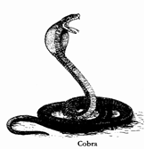Cobra
* Mamba (green mamba/black mamba)
* Death adder
* Viper (Gaboon viper/pit viper)
* Boomslang
* Coral snakes
* Rattlesnakes
* Water moccasins
* Taipan
* Sea snakes

**Reasons why people greatly fear the following venomous snakes**

**Gaboon viper**

* Its venom kills within 30 minutes

Gaboon viper is the most venomous snake on land

**Black mamba**

* It is always quick and ready to bite

**Cobra**

* It spits venom that can cause blindness

A cobra rarely bites

**A diagram showing the head of a venomous snake**

Elliptical eye pupil

Small hooked teeth

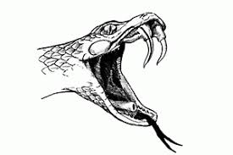

Venom duct

Forked tongue

Fangs

Venom gland

**Forked tongue**

* For smelling
* For tasting

**Small hooked teeth**

* For preventing the prey in mouth from escaping

**Venom gland**

* To produce/secrete venom

**Venom duct**

* It passes venom to fangs

**Fangs**

These are the two long pointed hollow teeth of venomous snakes

* For injecting venom
* For protection

**How are fangs adapted to injecting venom into the prey?**

* They are hollow

**Importance of venom to venomous snakes**

* It helps to kill the prey

**Dangers of snake venom to human life**

* It poisons blood leading to death
* It clots blood
* It destroys nerve cells
* It leads internal bleeding

By breaking the cells and tissues

* It paralyzes the heart

**Medical importance of snake venom**

* It is used to make antivenin/anti-venom serum

Each venomous snake has its own antivenin

**Why is it advisable to identify the colour, markings and shape of a snake in case of a snakebite?**

* To be given the right antivenin

**A diagram showing a bite of a venomous snake**

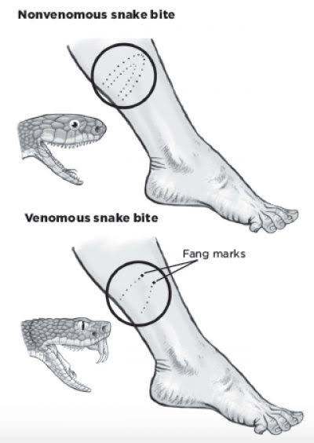

**Signs of venomous snakebite**

* Two puncture wounds/fang marks on the injured part
* Bleeding from the injured part
* Swelling of the injured part
* Excessive sweating

**First aid for snakebite**

* Keep the victim calm and at rest

To prevent venom from spreading in the body

* Tie a bandage slightly above the bitten part

To prevent the flow of venom to the heart

* Apply a blackstone

To absorb venom from the injured part

* Rush the victim to the hospital

**NON VENOMOUS SNAKES**

* These are snakes that do not have venom

**Characteristics of non-venomous snakes**

* They have no fangs
* They have round eye pupil
* They have round heads
* They have no venom
* They swallow their prey alive

**Examples of non-venomous snakes**

* Grass snake
* Milk snake
* Rat snake
* Hognose snake
* Garter snake

**Note**

Although they sometimes bite, they do not have venom

**A diagram showing a bite of a non-venomous snake**



**CONSTRICTORS**

These are very big snakes that kill their prey by squeezing them

**Characteristics of constrictors**

* They have no venom
* They kill their prey by squeezing them
* They have well developed teeth

To prevent the prey in mouth from escaping

**Why do constrictors lick their prey before swallowing?**

* To make them smooth (slippery)

**How does squeezing kill the prey?**

* It blocks the flow of blood

**Examples of constrictors**

* Python
* Anaconda
* Boa constrictor
* Bull snake
* Kingsnake

**DON’TS WITH A SNAKEBITE**

* Don’t apply ice on the snake bite

It causes frostbite (it blocks blood circulation)

* Don’t suck the wound with mouth

To prevent swallowing the venom

* Don’t cut across the wound.

To prevent causing more pain

* Don't apply a tourniquet

It makes the cells to be rapidly destroyed by concentrated venom

It blocks blood flow completely which can lead to amputation

* Don't try to capture the snake

To prevent the snake from biting you again

**What is amputation?**

* This is the surgical removal of a limb.

**How to prevent snake bites**

* Stay away from bushes
* Wear boots and gloves when working in a bush
* If you meet a snake, give it room to move away
* Never play with any snake
* Use torchlight at night

**Name any two snakes that give birth to live young ones**

* Boa constrictor
* Green anaconda
* Pit viper
* Garter snake
* Rattlesnake
* Sea snake

**LIZARDS**

These are reptiles with four limbs and a tail which can grow when it breaks off

**Characteristics of lizards**

* They have fleshy tongue
* They have movable eyelids
* They can regenerate their tails if the old one breaks
* They have suction/adhesive pads to grip smooth surfaces
* They undergo moulting
* They have four limbs
* They move by crawling
* They breathe by means of lungs
* They reproduce by laying eggs
* They undergo internal fertilization
* Most lizards are carnivorous animas

**Examples of lizards**

* Sinks
* Geckos
* Chameleons
* Anoles
* Agama lizards
* Monitor lizards
* Iguana lizards
* Komodo dragon

**Geckos**

These are small carnivorous nocturnal lizards

They are yellowish brown in colour

Wall geckos are commonly found in houses

Geckos protect themselves **by camouflaging**

**A diagram showing a gecko**

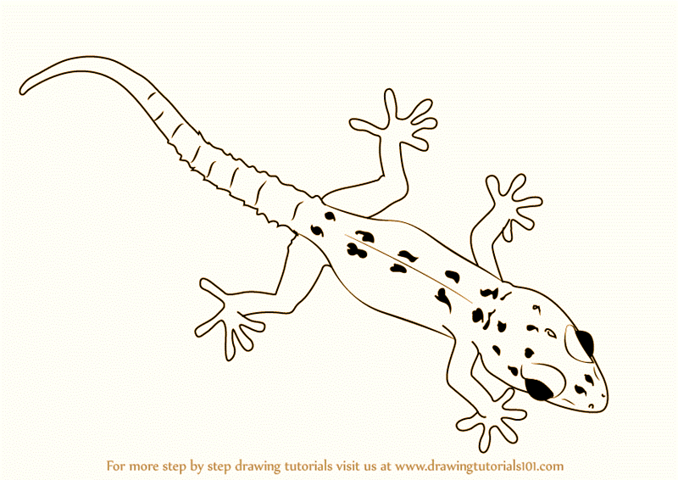

**How are wall geckos able to walk on vertical and upside-down surfaces?**

* They have adhesive/suction pads in their toes

**How are geckos useful in our houses?**

* They eat insect vectors like mosquitoes and cockroaches

**Skinks**

* They protect themselves **by breaking off their tails**

The tail moves and attracts the attention of the enemy

**Chameleon**

This is a slow moving lizard with a large head and bulging eyes

* It protects itself **by camouflaging/changing its skin colour**
* It can move its bulging eyes in all direction

To look front and back at the same time

* It uses its feet and tail **to hold small branches of trees**
* It has a long sticky tongue for **catching insects (trapping its prey)**
* Most chameleons **reproduce by laying eggs**

**Why does a chameleon camouflage/change its skin colour?**

* For protection
* To trap its prey

**How is a chameleon able to change colours?**

* It has chromatophores in its skin

**A diagram showing a chameleon trapping a housefly**

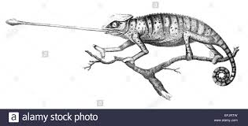

**Importance of chameleons in the environment**

* They eat insect vectors (e.g houseflies and mosquitoes)
* They eat insect pests

**CROCODILIANS (CROCODILES AND ALLIGATORS)**

These are the largest of reptiles

Alligators are commonly found in America

Crocodiles are commonly found in Africa

**Examples of crocodilians**

* Crocodile
* Alligator
* Gavial
* Caiman

**Characteristics of crocodiles and alligators**

* They have a strong tail

For swimming

For attacking their enemies

* They lay hard shelled eggs in sand
* They have strong pointed teeth

For biting their enemies

For tearing their prey

* They have strong jaws
* They have scales on their bodies

For protecting their bodies from injuries

* They have streamlined bodies

To reduce friction in water

* They reproduce by laying eggs
* They feed on prey after it had begun to rot
* They are lethargic/lazy animals

**Why do crocodiles sometimes gape/open their mouth widely?**

* To cool down body temperature/to cool themselves

**How do crocodiles protect themselves against enemies?**

* By biting using strong pointed teeth
* By attacking with its strong tail

**How is sun’s heat useful to female crocodiles?**

* Their eggs are hatched by sun’s heat

**A diagram showing a crocodile**

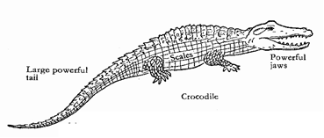

**Importance of reptiles to man**

* Some reptiles attract tourists e.g crocodiles
* Some reptiles eat insect pests e.g chameleon
* Some reptiles eat insect vectors e.g gecko
* Some reptiles are sources of food to man
* Their skins are sold for income
* They provide skins to leather industries
* They are used in biological research

**FISH**

These are cold blooded vertebrates with fins

**Characteristics of fish**

* They have fins

For swimming

For protection

* They have streamlined bodies

To reduce water resistance during movement

* They are cold blooded/poikilothermic animals
* They live in water/they are aquatic animals
* They breathe by means of gills
* They have a backbone
* They undergo external fertilization
* They have no eyelids
* Most fish have scales **except** catfish and mudfish
* They reproduce by laying eggs
* They have two chambered hearts
* They have no external ears
* Their body is divided into head, trunk and tail

**Examples of fish**

* Tilapia
* Nile perch
* Dogfish
* Trout
* Salmon
* Skates
* Catfish
* Sawfish
* Herring
* Cichlid
* Shark
* Stingray
* Tuna
* Codfish
* Cyprinid fish/minnow fish

**EXTERNAL FEATURES OF A FISH**

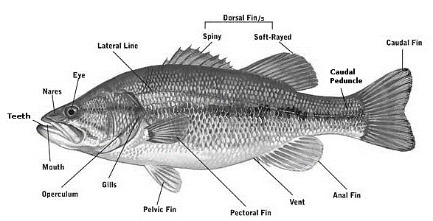

**FUNCTIONS OF EACH PARTS OF A FISH**

**Scales**

* To protect the skin from injuries

**Nostrils (nares)**

* For smelling food

**Eyes**

* For sight

**Operculum (gill cover)**

* It protects the gills

**Gills**

* For breathing

**Mouth**

* For feeding/for taking in food
* For taking in water with dissolved oxygen for breathing

**Lateral line**

* For detecting movements (vibrations) in water/for hearing
* For detecting pressure changes in water/for feeling

**Pectoral fin and Pelvic/ventral fin**

* For stopping/they act as brakes
* For swimming upwards or downwards in water
* For balancing

**Dorsal fin**

* For protection

It has spines

* For balancing/to prevent rolling in water

**Caudal fin (tailfin)**

* For increasing speed while swimming
* For swimming forward
* For turning/It acts as steering wheel

**Anal fin**

* For balancing/to prevent rolling in water

**Anus/vent**

* It passes out wastes
* It passes out the eggs

**TYPES OF FINS**

* Paired fins
* Median fins

**Paired fins**

These are fins arranged in pairs like limbs in other vertebrates

**Examples of paired fins**

* **Pectoral fin**

It acts as forelimbs/arms

* **Pelvic fin/ventral fin**

It acts as hind limbs/legs

**Medium fins**

These are single fins that run down the midline of the body of a fish

**Examples of medium fins**

* Caudal fin (tailfin)
* Dorsal fin
* Anal fin

**WAYS THROUGH WHICH FISH PROTECT THEMSELVES**

* Some fish use slippery scales to escape from enemies
* Some fish use spiny dorsal fin
* Some fish use electric organs e.g electric eel
* Some fish change colours/camouflage
* Some fish use their teeth to bite enemies
* Some fish inject venom e.g stingray

**BREATHING IN FISH**

* Fish breathe by means of gills
* They take in water with dissolved oxygen through the mouth
* Gill filaments absorb dissolved oxygen in water
* Water is passed out through the gill cover

**Give two similarities between a tilapia and a tadpole.**

* Both use gills for breathing
* Both live in water

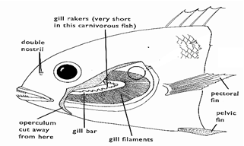**THE STRUCTURE OF FISH GILLS**

**Gill bar/gill arch**

* It holds/supports the gill rakers and gill filaments

**Gill rakers**

* They trap solid materials from damaging the gills
* For filtering food from water

**Gill filaments**

* For gaseous exchange/to absorb dissolved oxygen in water

**Adaptations of gill filaments to their function**

* They are numerous/very many in number

To increase the surface area for gaseous exchange

* They have a dense network of blood capillaries

To absorb oxygen from water

**Why does a fish die when removed from water?**

* It lacks dissolved oxygen

**TYPES (GROUPS) OF FISH**

* Bony fish
* Cartilaginous fish
* Lungfish

**Bony fish**

* They have no eye lids
* Their skeleton is made up of bones
* They have swim bladder **to keep the fish buoyant**
* They have gill cover/operculum to protect the gills
* 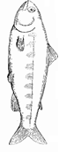They have overlapping scales (so that the free ends of the scales point backwards)

**Examples of bony fish**

* Nile perch
* Tilapia
* Salmon
* Trout
* Catfish
* Herrings
* Tuna
* Codfish
* Sardine

**Cartilaginous fish**

* They have tough and shiny skin
* They have gill slits instead of gill cover
* Their skeleton is made up of cartilage instead of bones
* They have no swim bladder

**Examples of cartilaginous fish**

* Shark
* 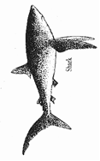Skates
* Ray/stingray
* Dogfish

**Lungfish**

* They breathe by means of gills and swim bladder modified as lungs
* They live in dirty pools, swamps or rivers
* They have long thin pelvic and pectoral fins
* They are inactive in dry seasons

**Why lungfish are called so**

* It has gills and lungs

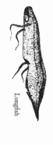**Examples of lungfish**

* African lungfish/ mudfish
* South American lungfish
* Australian lungfish

**Why does a lungfish take long to die when removed from water?**

* It can breathe using its swim bladder/its swim bladder is modified as lungs for breathing

**Why does lungfish aestivate/produce mucus that dries into cocoon around its body?**

* To survive drought

**THE SWIM BLADDER (AIR BLADDER)**

* It is a gas filled sac near the backbone of most fish

**Diagram showing a swim bladder**

**Uses of the swim bladder to a fish**

* It keeps the fish buoyant/it helps the fish to float in water/it controls the depth of fish in water
* It is used by some fish for breathing e.g lungfish
* It acts as sound producing organ
* It aids in hearing

**REPRODUCTION IN FISH**

* A fish reproduces **by laying eggs**
* Eggs of a fish are called **roe**
* Eggs of a fish (roe) are **fertilized externally**
* A fish undergoes **external fertilization**
* A young fish is called **fry**
* Most fish do not care for their young ones **except** tilapia

**FEEDING IN FISH**

* Fish feed on planktons (e.g wriggler, small insects and seaweeds)

**Planktons** are small organisms that float in water

* Some fish feed on other types of fish

**CLASSES OF FOOD BASED ON THEIR FEEDING HABITS**

* **Carnivores**

They feed on flesh e.g earthworms and wrigglers

Some carnivorous fish eat other fish/they are **piscivorous**

* **Herbivores**

They feed on plants.

They are grazed on leafy vegetables e.g spinach

* **Omnivores**

They feed on plants and flesh

* **Limnivores**

They feed on mud.

**KEEPING FISH**

* **Aquaculture** is the rearing of aquatic animals
* **Aquarium** is a transparent glass tank for keeping aquatic organisms
* Fish can be kept in ponds or aquarium
* Fish are kept in fresh water because **it is not salty**
* Aquaculturists in Uganda mainly keep **tilapia**

**State one biological method of controlling the spread of malaria**

* Keeping fish in ponds to feed on mosquito larvae and eggs

**ADAPTATIONS OF A FISH TO ITS LIFE IN WATER**

* They have fins for swimming
* They have gills for breathing in water
* They have streamlined bodies to overcome viscosity
* They have a swim bladder to make the fish float in water
* They have a lateral line to detect movements in water
* They have slippery scales for protection and to reduce viscosity

**METHODS OF CATCHING (HARVESTING) FISH**

* Use of basket
* Use of fishing nets (e.g trawling and purse seining)
* Use of hooks
* Use of spears
* Draining water from ponds

**METHODS OF PRESERVING FISH**

* Refrigeration

Modern methods

* Canning (tinning)
* Smoking

Local methods

* Sundrying
* Salting

**How does smoking, sundrying or salting preserve fish?**

* By absorbing moisture from fish

**How does refrigeration preserve fish?**

* By preventing the multiplication of germs

**USES (IMPORTANCE) OF FISH TO PEOPLE**

* They are source of food (they are source of proteins and calcium)
* Their bones are used to make glue
* They are source of income when sold
* Fish in aquarium is used to decorate houses
* Fishing is an employment
* Fish reduce spread of malaria by feeding on mosquito larvae
* Fishing industry gives revenue to the government
* Fish oil is used to make paint
* Cod liver oil from codfish is rich in vitamin A and B

**NOTE:**

* **Oviparous animals** are animals which lay eggs
* **Viviparous animals** are animals which produce living young ones
* **Ovoviviparous animals** are animals that give birth to live young ones from the eggs that hatch inside its body
* **Terrestrial animals** are animals which mainly live on land
* **Aquatic animals**  are animals that live in water
* **Amphibious animals**  are animals that live in water and on land
* **Nocturnal animals**  are animals that are active at night
* **Diurnal animals**  are animals that are active during day time
* **Tetrapods** are animals with four limbs or descended from four limbed animals

**INVERTEBRATES**

* These are animals without a backbone/spine/vertebral column

**Characteristics of invertebrates**

* They do not have a backbone
* They are multicellular animals
* They have soft bodies

**Classes (groups) of invertebrates**

* Coelenterates
* Echinoderms
* Sponges
* Worms
* Molluscs
* Arthropods

**COELENTERATES (CNIDARIANS)**

These are soft bodied invertebrates with only one body opening.

**Characteristics of coelenterates**

* They live in seawater
* They have stinging cells/cnidocytes

For protection

For paralyzing their prey

* They have only one body opening

It acts as mouth and anus

* They have tentacles

For holding food

For holding stinging cells

* They reproduce by budding
* They hydrostatic skeleton
* They have cylindrical bodies with two layers (e.g endoderm and ectoderm)

**Examples of coelenterates**

* Jellyfish
* Hydra: it moves by floating, gliding or somersaulting
* Corals
* Sea anemone
* Sea pen
* Sea fan
* Sea whip

**A diagram showing coelenterate**

**ECHINODERMS**

These are spiny skinned invertebrates with tube feet

They are exclusively marine animals

**Characteristics of echinoderms**

* They have no heads
* They have spiny skins
* They have water vascular system
* They have a true coelom
* Most have five arms

For holding food

* They have tube feet

For movement/locomotion

**Examples of Echinoderms**

* Starfish/sea star
* Sea urchin
* Sand dollar
* Sea lily
* Sea cucumber
* Brittle star

**Diagrams showing echinoderms (Starfish, brittle star and sea urchin)**

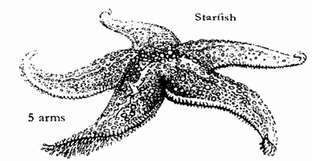

**WORMS**

* These are long thin soft bodied invertebrates

**Characteristics of worms**

* They breathe through their moist skins
* They reproduceby laying eggs
* They have hydrostatic skeleton

Some worms live in soil or water while others live inside other animals as parasites

* **Parasite** is an organism which depends on another organism for survival without killing it
* **Host** is an organism on or in which a parasite lives

**Groups (classes) of worms**

* Segmented worms (annelids)
* Round worms (nematodes)
* Flatworms (platyhelminthes)

**SEGMENTED WORMS (ANNELIDS)**

* These are worms with segmented bodies

They are also called **ringed worms**

They mostly live in soil and water

**Characteristics of segmented worms (annelids)**

* They are segmented
* They are hermaphrodites

**Examples of segmented worms**

* Leech
* Earth worm
* Lugworm (it is used as bait in fishing)
* Bristle worm
* Sandworm: it lives in sand or mud

**Diagram of earthworm, leech and bristle worm**

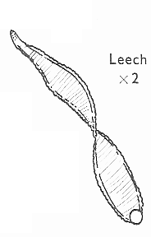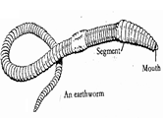

**EARTHWORM**

* It lives in soil
* It feeds on soil or decayed vegetation
* Their mouth is on anterior end and arms on the posterior end
* It reproduces by laying eggs
* It has sexual reproduction
* It breathes through **its moist skin**
* The skin is kept moist by the **secretions from tiny glands**
* It is hermaphrodite

**Hermaphrodites** are animals which have both male and female reproductive organs

* Earthworms undergo regeneration

**REGENERATION IN WORMS**

* This is the ability of segmented worms to repair their injured parts

**How are chaetae important to an earthworm?**

* For gripping the ground during movement

**Of what importance is clitellum to an earthworm?**

* It produces the fluid in which eggs are deposited.

**Why do earthworms come out of the ground when it rains?**

* To get oxygen

**Why do earthworms die when oil is poured onto it?**

* Oil cuts off oxygen supply to the moist skin
* Oil closes its breathing holes

**Importance of earthworms to people**

* They aerate the soil
* They improve soil drainage
* They break down organic matter
* They are used as fishing baits

**How do earthworms improve soil aeration and drainage?**

* By making holes in the soil (digging channels)

**FLATWORMS (PLATY HELMINTHES)**

* These are worms with thin flattened bodies

**Characteristics of flat worms**

* They have a flat body
* They are hermaphrodites
* Many of them are parasites

**Examples of flat worms**

* Tapeworm
* Liver fluke
* Schistosome (blood fluke):**causes bilharziasis or schistosomiasis**
* Pond flatworm

**TAPEWORM**

A tapeworm is a hermaphrodite (has both male and female reproductive organs)

It reproduces by laying eggs into the host

It is an endoparasite in animals

It is an intestinal worm which stays in the small intestines

It feeds on digested food in the small intestines

**How do tape worms enter (penetrate) into the body?**

* Through eating infested half cooked meat or fish

**Diagram showing tapeworm**

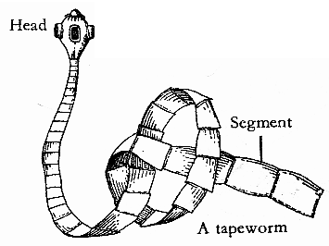

**Hooks and suckers**

* For attachment

**Porous body**

* To absorb digested food

**Segments**

* To store eggs

**Scolex**

This is the head of tapeworm

* It holds the hooks and suckers

**Why does a tapeworm lack the digestive system?**

* It feeds on already digested food

**Why can’t tapeworms be digested by the host’s digestive juices?**

* They produce a substance that neutralizes the digestive juice

**Why can’t tapeworms be moved during peristalsis?**

* They have hooks and suckers for firm attachment.

**Signs of tapeworm infestation**

* Diarrhoea
* Indigestion

**Effects of tapeworm infestation**

* It leads to hydatid disease (echinococcosis)

**Control of tapeworm infestation**

* Feeding on well cooked meat
* Deworming

**LIVER FLUKE**

It is found in the liver of infested animals

It causes **liver rot** in sheep

**Diagram showing liver fluke**

**ROUNDWORMS (nematodes)**

* These are unsegmented worms with a streamlined rounded body

**Characteristics of roundworms**

* Their body is pointed at both ends
* They have no segments
* They have a cylindrical body (rounded body)

**Signs of roundworm infestation**

* Loss of appetite
* Dullness

**Symptoms of roundworm infestations**

* General body weakness

E**xamples of roundworms**

* Hookworm
* Eelworm (it affects plants)
* Threadworms (pinworm)
* Ascaris:
* Filaria worm: **causes elephantiasis or filariasis**
* Onchocerca volvulus: **causes onchocerciasis or river blindness**

**HOOKWORM**

* It lives small intestines
* It feeds on blood

**A diagram showing a hookworm**

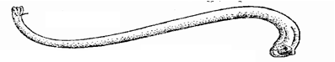

**How do hookworms enter our bodies?**

* By penetrating through the bare skin

**Effects of hookworm infestation**

* They lead to hookworm anaemia

**Prevention of hookworm infestation**

* Always wear shoes
* Deworming

**ASCARIS**

* It is pink or white in colour
* It spreads through eating dirty fruits and vegetables which are eaten raw
* It spreads through drinking contaminated water
* It affects people and apes

**Control of ascaris**

* Always drink clean boiled water
* Wash fruits and vegetables before they are eaten

**MOLLUSCS (MOLLUSKS)**

These are soft bodied invertebrates with a mantle

They live in water and on land

**Characteristics of molluscs**

* They have soft bodies
* They have no segments
* They have a mantle

To produce the shell

* Most of them have a shell

For protection

* Mollusks reproduce by laying eggs.

**Examples of molluscs (mollusks)**

* 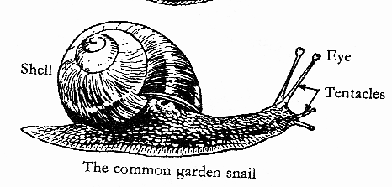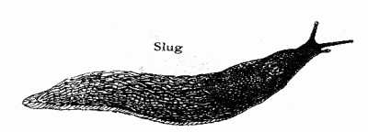Snail
* Slug
* Squid
* Octopus
* Clam
* 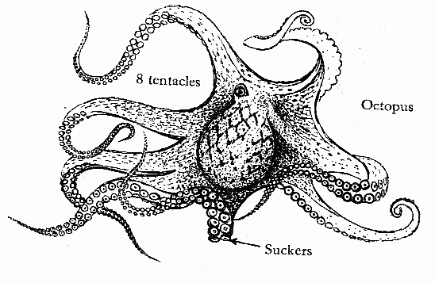Oyster
* Mussel
* Cuttlefish: it ejects dark ink for protection
* 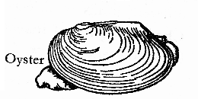Scallop
* Mussel
* Chiton
* Nautilus
* Conch
* Cowrie

**Octopus** has no shells

**Why are octopi, squids and cuttlefish regarded as the most intelligent mollusks?**

* They have well developed heads and tentacles

**How do octopus and squids move?**

* By jet propulsion

**UNIVALVES AND BIVALVES**

**Univalves:**

* These are molluscs with a shell having one piece

**Examples of univalves**

* Snail
* Conch

**Bivalves:**

* These are molluscs with a shell having two hinged pieces

**Examples of bivalves**

* Scallop
* Clam
* Mussel
* Oyster

**SNAIL**

* It has a soft body with a shell
* It feeds on vegetation
* It protects itself **by hiding in its shell**
* Its body is made up of spiral coils
* Older snails have more coils than the young ones
* It breathes through **the breathing pore near the entrance of the shell**
* It reproduces by laying eggs
* It is hermaphrodite (it has both male and female reproductive organs)
* Snails live on land and in water

**Groups of snails**

* Water snails
* Garden snails (land snails)

**NOTE:**

* Snails have shells **while** slugs have no shells

**IMPORTANCE OF MOLLUSCS**

* Some molluscs are eaten as food (some snails and octopus are source of proteins when eaten)

**DANGERS OF MOLLUSCS**

* Garden snails are crop pests
* Water snails spread bilharziasis

**How are molluscs different from other invertebrates?**

* They have soft bodies with a protective shell or mantle

**DIAGRAM SHOWING SNAIL, SLUG AND OCTOPUS**

**SPONGES**

These are marine invertebrates which live permanently attached to rocks at the sea floor

* They are sometimes called **poriferans**
* Porifera means pore bearing
* They have porous internal skeleton of silica
* They cannot move about
* They feed on tiny pieces of food in sea water
* They breathe and feed **through the pores or ostia on their body (their porous bodies)**
* Sponges can reproduce sexually or asexually by **fragmentation or by producing gemmules**
* Sponges can regenerate parts of its body or even the entire body from fragments

**Why are sponges regarded as primitive (simplest) animals?**

* They do not move (are sedentary or sessile)
* They lack nerves, muscles and internal organs
* They lack head, mouth, digestive, circulatory or nervous system.
* They have no body symmetry

**Examples of sponges**

* Bath sponge: its skeleton is made up of a flexible protein called spongin
* Glass sponge
* Silk cup sponge
* Calcareous sponge

**Uses of sponges to people**

* They are used as bath aids
* For wall painting
* For dish and car washing
* For art and craft
* They are used as cleaning tools
* They are used as drinking vessels

**Why are sponges different from other invertebrates?**

* They do not move

**ARTHROPODS**

These are invertebrates with jointed legs and segmented bodies

**Characteristics of arthropods**

* They have jointed legs
* They have segmented bodies.
* They have exoskeleton

**Importance of exoskeleton to arthropods**

* It protects the body
* It gives the body shape
* It protects the body from drying out

**Disadvantages of an exoskeleton**

* It prevents growth
* It increases body weight

**Moulting (ecdysis)**

This is the shedding of the skin or exoskeleton in some animals

Arthropods undergo moulting (ecdysis)

**Why do arthropods moult (undergo moulting or ecdysis)?**

* To increase in size (to grow)

**Disadvantage of moulting in some animals**

* The animal may dry out
* The animal may be eaten by predators

**Examples of arthropods**

* Millipede
* Centipede
* Crab
* Lobster
* Mite
* Tick
* Spider
* Housefly
* Moth
* Butterfly
* Mosquito

**Groups (classes) of arthropods**

* Myriapods
* Arachnids
* Crustaceans
* Insects

**MYRIAPODS**

These are arthropods with many legs and many segments

They have 20 or more legs

They can regrow new legs if they lose some legs

**Groups of myriapods**

* Centipedes (chilopoda)
* Millipedes (diplopoda)

**Diagrams showing a centipede and a millipede**

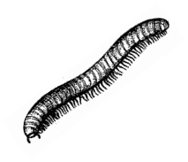

**Centipede Millipede**

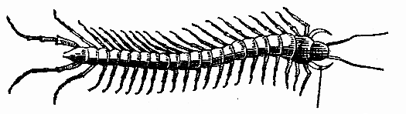

**Centipedes (chilopoda)**

* They have one pair of legs on each segment
* Their first pair of legs is modified into poison fangs
* They are nocturnal animals (mostly active at night)
* They can move quickly
* They breathe **through spiracles**
* They are carnivores
* They feed on insects, worms and spiders

**How do centipedes protect themselves?**

* By biting using poison claws

**How are poison claws useful to a centipede?**

* For biting enemies
* For killing the prey

**Millipedes (diplopoda)**

* They have two pairs of legs on each segment
* They are herbivores
* They feed on decaying leaves
* They breathe through spiracles
* They are mostly active at night
* They are move slowly

**How do millipedes protect themselves?**

* By curling (coiling)
* By producing bad smell

**DIFFERENCES BETWEEN MILLIPEDES AND CENTIPEDES**

* Millipedes have two pairs of legs in each segment while centipedes have one pair of legs on each segment
* Millipedes are herbivores while centipedes are carnivores
* Millipedes have many segments than centipedes
* Millipede protect themselves by curling while centipedes protect themselves by biting using poison claws

**Advantages of myriapods**

* Millipedes help in soil aeration
* Millipedes recycle nutrients in the soil
* Centipedes eat insect vectors like flies and cockroaches

**Dangers of myriapods**

* Millipedes are crop pests (destroy root tubers)
* Centipedes bite people
* Millipedes produce bad smell that causes allergic reactions to some people

**CRUSTACEANS**

* These are arthropods with a hard crusty skin

**Characteristics of crustaceans**

* They have two main parts

Abdomen

Cephalothorax (fused head and thorax)

* They breathe through gills
* They live in water or wet places
* They have 10 to 14 legs
* They have 2 pairs of antennae

Some crustaceans feed on worms and insects while others feed on vegetation

**Examples crustaceans**

* Crab
* Prawn
* Lobster
* Shrimp
* Woodlice
* Barnacle
* Crayfish
* Water flea
* Sand flea (sandhopper)
* Krill

**Importance of crustaceans**

* They are eaten as food by people
* Some of them are used as baits in fishing
* They are source of income when sold in hotels

**Diagrams showing lobster, crab and prawn**

**Uses of appendages to crustaceans**

* For feeding
* For walking
* They act as sense organs

**Uses of swimmerets to crustaceans**

* For swimming
* For catching food
* Some crustaceans use them for brooding the eggs

**ARACHNIDS**

These are arthropods with 2 main body parts and 8 legs

**Characteristics of arachnids**

* They have eight legs (four pairs of legs)
* They breathe through book lungs (lung books)
* They have 2 main body parts;

Cephalothorax (prosoma)

Abdomen (opithosoma)

* They have no antennae

**Examples of arachnids**

* Spider
* Tick
* Scorpion
* Mite
* Harvestman

**Spider**

* They breathe through book lungs (lung books)
* They have two poison fangs near the mouth **to kill (paralyze) the prey**
* They reproduce by laying eggs
* They have **spinnerets** on the abdomen

**A diagram showing a spider**

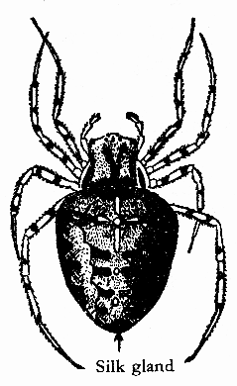

**How do spiders protect themselves?**

* By injecting venom into their enemies

**Importance of spinneret to spider**

* To produce silk
* To spin spiderweb

**Reasons why spiders produce silk**

* To make spiderwebs
* To trap prey

**Why do spiders make spiderwebs? (Importance of spiderwebs to spider)**

* To trap prey
* For movement
* For protection
* To encase egg sacs

**STRUCTURE OF SPIDERWEB**

**Importance of spiders to people**

* They feed on insect vectors e.g mosquitoes and houseflies

**Tick and mite**

* They live as ectoparasites on animals
* They are parasites and vectors
* They obtain food **by sucking blood from the host**

**Host** is an organism on or in which a parasite lives

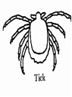**A diagram showing a tick**

**How are ticks and mites harmful to cattle keepers?**

* Ticks and mites are cattle parasites

**Examples of tickborne diseases**

**In farm animals (livestock)**

* Heart water
* East coast fever
* Anaplasmosis
* Red water

**In people**

* Lyme disease
* Relapsing fever
* Typhus fever

**Scorpions**

* They have a large tail with a poison sting
* Their front legs are modified into pincers
* They produce (give birth) to live young ones

**A diagram showing a scorpion**

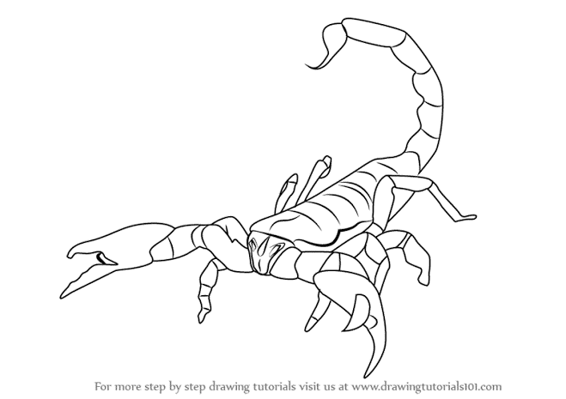

**How do scorpions protect themselves?**

* By using its poison stinger on the tail
* By biting using its pincers

**INSECTS**

These are arthropods with 3 main body parts and 6 legs.

**Characteristics of insects**

* They have 3 main body parts (head, thorax and abdomen)
* They have 6 legs
* They breathe through spiracles

**Note**

They reproduce by laying eggs

They have an exoskeleton

They undergo internal fertilization

**Examples of insects**

* Tsetse fly
* Housefly
* Mosquito
* Grasshopper
* Butterfly
* Cockroach
* Ants (safari ants, white ants, black ants and red ants)
* Sandfly
* Beetle
* Locust
* Midge
* Blowfly
* Cricket

**Examples of wingless insects (insects without wings)**

* Red ants
* Safari ants
* Termites
* Silverfish
* Lice
* Fleas
* Firebrats

**Examples of insects with a stinger**

* Worker bees
* Wasp

**Examples of edible insects (insects which are eaten by people)**

* Grasshoppers
* White ants
* Crickets
* Termites

**Examples of dangerous insects to people**

* Mosquito
* Flea
* Housefly
* Blackfly
* Bedbug
* Tsetse fly
* Locust
* Bumblebee
* Cockroach

**GROUPS OF INSECTS**

* Social insects
* Solitary insects

**Social insects**

* These are insects which live and work together

They live in a colony

**Examples of social insects**

* Termites
* Ants
* Wasps
* Honeybees

**Solitary insects**

* These are insects which do not live and work together

They live alone

**Examples of solitary insects**

* Mosquitoes
* Houseflies
* Butterflies
* Carpenter bees
* Mining bees
* Dragon flies
* Leafcutter bees

**THE THREE MAIN BODY PARTS OF AN INSECT**

**THE HEAD**

It has the eyes, antennae and mouth parts.

**Compound eyes**

* For sight

**Antennae (feelers)**

These are sense organs for;

* Feeling
* Smelling
* Hearing
* Tasting
* Detecting change in temperature and humidity
* Finding direction

**Mouth parts**

**Proboscis**

* For sucking food (plant fluids and blood)

Insects with proboscis include; bees, moths, mosquitoes, butterflies and tsetse flies

**Mandibles**

* For cutting and grinding food

Insects with mandibles include; grasshoppers, locusts and cockroaches

**THE THORAX**

* It has the legs and wings
* It has three segments (pro, meso and metathorax)
* Each segment has two legs

**Legs (appendages)**

* For locomotion (movement)
* For capturing the prey
* For grasping the females during mating

Their feet have **sticky pads** to walk on smooth surfaces

Their feet have **tarsal claws** to grip and walk on rough surfaces

**Wings**

* For flight

**DIPTERANS (DIPTEROUS INSECTS)**

These are insects with two wings

* They have **halteres**

For balancing during flight

* They have **proboscis**

For sucking food

* Their larvae are called **maggots**

**Examples of two winged insects (dipterans)**

* Housefly
* Mosquito
* Black fly
* Sandfly
* Cranefly
* Tsetse fly

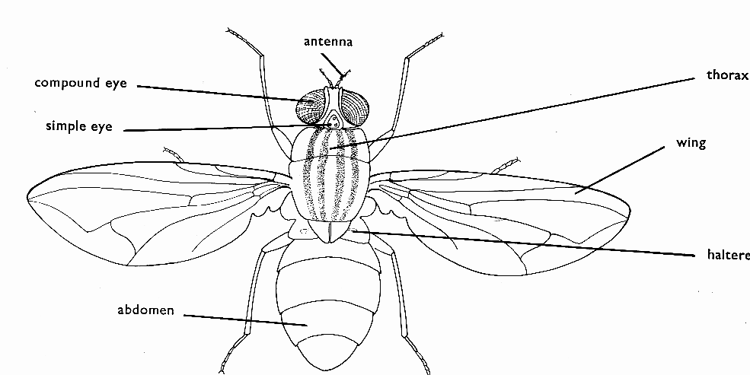**A diagram showing parts of a housefly (dipteran insect)**

**ABDOMEN**

It is the largest main body part of an insect

* It has spiracles

For breathing

* Female insects have a reproductive organ called **ovipositor**

For laying eggs

* Some insects have **a stinger**

For protection (for stinging their enemies)

**LIFE CYCLE (METAMORPHOSIS)**

This is transformation of an organism during the stages of development

**Types of life cycle (metamorphosis)**

* Complete metamorphosis (complete life cycle)
* Incomplete metamorphosis (incomplete lifecycle)

**COMPLETE LIFE CYCLE**

This is a life cycle which has four stages of development

Eggs – Larva – Pupa – Adult

**Examples of insects which undergo complete metamorphosis**

* Houseflies
* Mosquitoes
* Butterflies
* Bees
* Moth
* Wasps
* Tsetse flies
* Fleas

**HOUSEFLY**

Female houseflies lay their eggs on decaying matter like;

* manure heaps
* faeces
* rubbish pits

**A diagram showing the life cycle of a housefly**

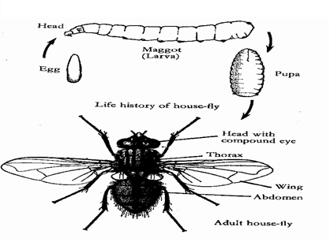

* Houseflies undergo complete life cycle
* They lay eggs which hatch into larvae
* The larvae are called **maggots**
* Maggots feed on **decaying matter**
* The larvae (maggots) turn into **pupae**
* The pupa is a **dormant stage**

It neither feeds nor moves

* The pupa grows inside a protective case called **cocoon**

The cocoon protects the pupa

* The pupae develop into adults
* An adult housefly is called **imago**
* Adult houseflies have two wings (they are dipterans)

**Why do houseflies lay their eggs in decaying matter?**

* For the larvae (maggots) to get food

**How are maggots useful in pit latrines and sewage tanks?**

* They reduce the volume of faeces

**How do maggots reduce the volume of faeces?**

* By feeding on faeces

**Dangers (economic importance) of houseflies**

* They are insect vectors (they carry germs which cause diseases)
* They help in disposal of rotting matter by feeding on it.

**How is a housefly able to carry germs?**

* It has a hairy body

**How do houseflies spread germs?**

* By spitting saliva on food (vomiting juices on food)
* By defecating on food when feeding

**State the importance of glandular pads in the feet of a housefly.**

* They help a housefly to walk on smooth surfaces and upside down.

**Diseases transmitted by a housefly**

* Diarrhoea
* Cholera
* Typhoid
* Trachoma
* Dysentery

**Control of houseflies**

* Spraying with insecticides
* Disposing faeces in latrines
* Disposing rubbish in rubbish pits
* Smoking ordinary pit latrines
* Covering dustbins
* Burying kitchen refuse

**MOSQUITOES**

* They lay their eggs in stagnant water
* Their larva stage is called **wriggler**
* The larva (wriggler) breathes through **siphon**
* Its pupa stage is called **tumbler**
* The pupa breathes through **trumpet**
* An adult stage is called **imago**

**How does the wriggler (larva stage of a mosquito) move?**

* By wriggling

**Types of mosquitoes**

* Anopheles mosquito
* Culex mosquito
* Aedes (tiger) mosquito

**Diagrams showing life cycles of anopheles and culex mosquitoes**

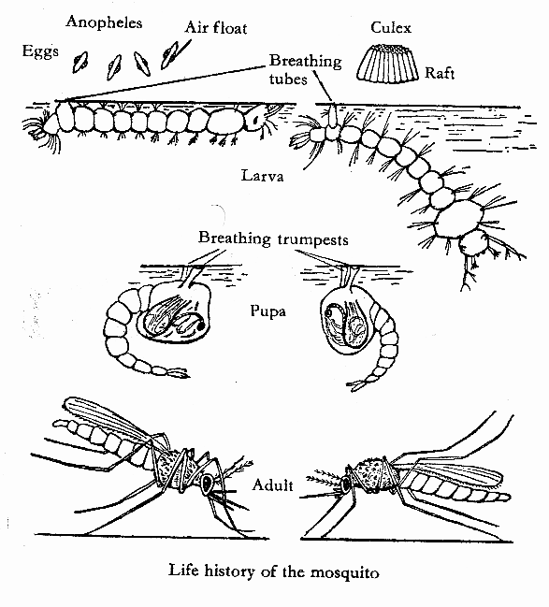

**Differences between anopheles and culex mosquitoes**

|  |  |
| --- | --- |
| **Anopheles mosquito** | **Culex mosquito** |
| Lays eggs with an air floats; to enable them float on water | Lays eggs in rafts |
| Larva lies parallel to the water surface | Larva lies at an angle to the water surface |
| Adult stands at an angle when at rest | Adult stands flat horizontally when at rest. |

**Why can’t female anopheles mosquito spread HIV/AIDS yet it feeds on blood?**

* HIV is destroyed by the enzymes in the digestive tract of a mosquito

**OR**

* HIV is destroyed in the body of a mosquito

**LIFE HISTORY OF MOSQUITOES**

* Mosquitoes feed on nectar and plant juices
* Male mosquitoes do not suck blood
* Female mosquitoes suck blood **to develop their eggs**
* Female anopheles mosquitoes spread malaria
* Malaria is caused by a protozoan germ called **plasmodium**
* Culex mosquitoes spread **elephantiasis (filariasis)**
* Elephantiasis is caused by **filaria worm**
* Aedes (tiger) mosquito spreads **yellow fever, dengue fever, zika fever and chikungunya fever**
* Yellow fever, dengue fever and chikungunya fever are caused by **a virus** and can be prevented by **immunisation**

**WAYS OF CONTROLLING MOSQUITOES**

**Control of mosquitoes without using chemicals**

* Drain stagnant water around homes
* Clear all bushes around homes
* Keep fish in ponds to eat mosquito larvae (wrigglers)
* Use of electric mosquito traps
* Close doors and windows early in the evening
* Use mosquito repellant plants in the compound like basil and lemon balm
* Burn broken plastic tins and bottles where mosquitoes can breed

**Biological control of mosquitoes**

* Keep fish in ponds to feed on mosquito larvae
* Put mosquito repellant plants in the compound

**Chemical control of mosquitoes**

* Pour oil on stagnant water

Oil cuts off oxygen supply to mosquito larvae

* Spray adult mosquitoes with insecticides
* Sleep under treated mosquito nets
* Apply mosquito repellant vaseline on your body
* Use of mosquito coils

**BUTTERFLIES AND MOTH**

* Butterflies and moths **protect themselves by camouflaging**
* They undergo complete metamorphosis

Eggs – Larva (caterpillar) – Pupa (chrysalis) – Adult (imago)

* Female lays eggs on the surface of leaves
* Eggs hatch into larva called caterpillar
* Caterpillar feeds on leaves

**Why butterflies and moths lay their eggs on leaves**

* To enable their larvae get food
* Larva is protected by cocoon from which it develops into pupa
* Pupa (chrysalis) neither feeds nor moves (it is dormant)
* Adult breaks the cocoon and comes out when it is fully grown
* Moths are **nocturnal insects** (then are mostly active at night)
* They pollinate scented flowers at night. Other nocturnal insect pollinators are **beetles (ladybirds)**

**How are moths and beetles able to pollinate flowers at night?**

* They have a good sense of smell

**How a moth and butterfly protect themselves against enemies?**

* They camouflage to confuse the predators
* Some moth have large two dots on its wings which look like eyes

**How do caterpillars protect themselves?**

* They use their prickly hair

**Advantages of butterflies and moths**

* They pollinate flowers of crops
* They eat weedy plants
* Some caterpillars are eaten as food
* They are used in advertisements to show health environment

**Disadvantages of butterflies and moths**

* Their larvae destroy crops (caterpillar is a crop pest)
* Caterpillars have prickly (bristle) hairs which cause itching on the skin

**DIFFERENCES BETWEEN BUTTERFLY AND MOTH**

|  |  |
| --- | --- |
| **BUTTERFLY** | **MOTH** |
| Active during day time (it is diurnal) | Active at night (it is nocturnal) |
| Has smooth body | Has hairy body |
| Has bright colours | Has dull colours |
| Has clubbed (long thin) antennae | Has short feathery antennae |
| Has slender body | Has stout body |
| Has rectangular wings | Has triangular wings |
| Rests with their wings closed | Rests with their wings open |

**TSETSE FLIES**

* They suck blood from animals and people for food
* They have a complete life cycle
* Their eggs hatch inside their body

**Where do female tsetse flies lay their eggs?**

* Female tsetse flies do not lay eggs but produce larvae

**Why tsetse flies are called ovoviviparous insects**

* Their eggs hatch inside their body and produce larvae

**Why do tsetse flies produce larvae instead of laying eggs?**

* Its environment does not favour laying eggs

**Diseases transmitted through tsetse fly bites**

* **Nagana :** in farm animals
* **Sleeping sickness:** in people

**INCOMPLETE METAMORPHOSIS**

This is a life cycle with three stages of development

**Eggs – Nymph – Adult (imago)**

**Nymph** is the second stage of the incomplete life cycle

**Imago** is an adult stage in the life cycle of an insect

After moulting, the nymph develops wings and becomes a fully adult.

**Differences between nymph and adult**

* Nymph has no wings (it is wingless) but adult has wings
* Nymph is always smaller than adult

**Examples of insects which undergo incomplete metamorphosis**

* Cockroach
* Grasshopper
* Dragonfly
* Bedbug
* White ant
* Cricket
* Locust
* Termite
* Aphid
* Praying mantis
* Walking sticks
* Katydid

Cockroaches are **nocturnal insects** (active at night)

**A diagram showing life cycle of a cockroach**

* 1 is the egg
* 2 is the nymph
* 3 is the adult

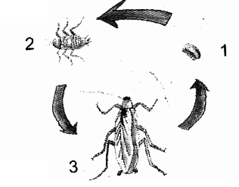

**Diseases transmitted by cockroaches**

* Leprosy
* Poliomyelitis (polio)
* Cholera
* Typhoid
* Diarrhoea

**Why do insects moult?**

* To increase in size (to grow)

**IMPORTANCE OF INSECTS**

* Some insects like moths and bees pollinate flowers of crops
* Some insects like white ants are edible
* Bees provide honey and wax
* Grasshoppers are sold for income

**DANGERS OF INSECTS**

* Some insects are vectors (spread germs)
* Some insects are crop pests (destroy crops)
* Some insects sting people
* Termites destroy wood and local houses

**PROTISTA KINGDOM (single called organisms)**

* This is a kingdom of simple organisms with one cell
* Members of this kingdom are unicellular organisms
* They have a nucleus enclosed in a membrane
* They are neither plants, fungi, bacteria nor animals.
* They live in liquids or in other organisms **to prevent themselves from drying out**

**Examples of Protista**

* Algae
* Euglena
* Protozoa

**ALGAE**

* They have no roots, stems and leaves
* They have chlorophyll and can make their own food
* Larger algae reproduce by **means of spores.**
* Smaller algae reproduce by **fragmentation**
* They are found in water and moist places

**What is algal bloom?**

* This is the dense spread of algae on water surface.

**Examples of algae**

* Fucus
* Spirogyra
* Seaweeds (giant kelp)
* Diatom
* Nostoc

**Types of algae**

* Red algae
* Green algae
* Brown algae

**Importance of algae**

* They act as food for aquatic animals
* They are a source of iodine when eaten
* They are used as fertilizers
* They provide oxygen to aquatic animals
* They are used to make biofuels (algal biofuel)

**PROTOZOA**

* These are unicellular organisms with nucleus and cytoplasm.
* Protozoa are microscopic **because** they can only be seen using a microscope
* Protozoa are unicellular **because** they have one cell
* They do not have chlorophyll
* Amoeba uses **pseudopodia (false feet)** for locomotion/movement and feeding
* Paramecium uses **cilia** for locomotion and feeding
* They are found in fresh water, damp places and in bodies of animals as parasites.
* They reproduce by **binary fission**

**Examples of protozoa**

* Amoeba
* Plasmodium
* Paramecium
* Trypanosome

**Protozoan diseases in humans**

|  |  |
| --- | --- |
| **PROTOZOA** | **PROTOZOAN DISEASE** |
| Plasmodium | Malaria |
| Trypanosome | Sleeping sickness |
| Amoeba | Amoebic dysentery |

**DIAGRAMS SHOWING AMOEBA AND PARAMECIUM**

**Amoeba Paramecium**

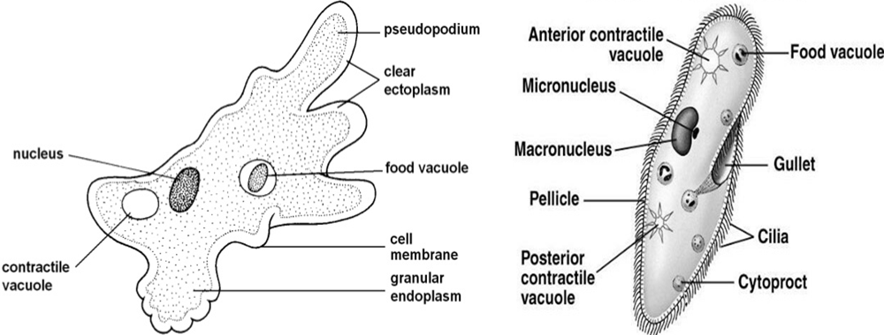

An amoeba reproduces by **binary fission**

Binary fission is an example of **asexual reproduction**

**Binary fission** is the process by which the cell divides into two identical daughter cells

**EUGLENA**

* This is a unicellular organism which has both plants and animal features.
* It has chlorophyll so makes its own food.
* It can move from one place to another very quickly for protection
* It uses **flagella** for locomotion (movement) and feeding
* It is microscopic and lives in ditches and ponds.

**FUNGI KINGDOM**

These are simple organisms that lack chlorophyll and exist as a mass of threads called hyphae or mycelium.

They grow where there is **moisture**

They do not have leaves, stem and roots

They have saprophytic nutrition (feed on decaying organic matter)

Fungi are able to live as **saprophytes** or **parasites**

**Saprophytes** are organisms that feed on dead decaying matter

**Parasites** are organisms that depend on other host for survival

**A host** is an organism on which a parasite depends

**EXAMPLES OF FUNGI**

* Mushrooms
* Toadstools
* Yeast
* Moulds
* Mildews
* Puffballs
* Clubroot fungus
* Bracket fungus

**HOW DO FUNGI FEED?**

* They feed saprophytically
* Some fungi feed parasitically

**HOW DO FUNGI REPRODUCE?**

* Most fungi reproduce by means of spores
* Yeast reproduces by budding

**A diagram showing budding in yeast**

**STRUCTURE OF A MUSHROOM**

**FUNCTIONS OF EACH PART OF A MUSHROOM**

**Hyphae**

* They absorb digested food from decaying matter

**Mycelium**

* It is the vegetative part of a mushroom

**Gills**

* They produce and store spores

**Cap**

* It protects the gills

**Stipe**

* It holds the cap and gills

**Examples of moulds**

* Mucor
* Rhizopus
* Penicillium

**Advantages of fungi**

* Moulds help in decomposition of organic matter to form humus
* Some mushrooms are eaten as food by people (mushrooms are rich in proteins and mineral salts)
* Some fungi are used in making medicine (penicillium moulds are used to penicillin)
* Yeast help in flavouring cheese
* Yeast is used fermentation of alcohol
* Yeast is used in making breads
* Yeast is a source of vitamin B1

**Disadvantages of fungi**

* Toadstools are poisonous to people when eaten
* Some fungi cause food to go bad (cause food poisoning)
* Some fungi cause fungal diseases in plants and animals

**Examples of fungal diseases in people**

* Ringworm
* Athlete’s foot
* Jock itch
* Candidiasis
* Barbers itch

**Examples of fungal diseases in plants**

* Potato blight
* Maize rust
* Tomato blight

**CARE FOR AND PROTECTION OF VERTEBRATES AND INVERTEBRATES**

* Train trainable animals
* Treat sick animals
* Clean houses for animals
* Gazette areas as game parks and game
* Game parks protect animals from becoming extinct or endangered
* Regular vaccination of animals
* Enforce strict laws against poaching

**ANIMALS’ FREEDOM**

* Freedom from fear
* Freedom from pain
* Freedom from hunger
* Freedom from discomfort
* Freedom of reproduction

**ENERGY**

This is the ability of the body to do work.

**Types of energy**

* **Kinetic energy**

This is the type of energy possessed by a body in motion (moving body)

* **Potential energy**

This is the type of energy possessed by a body at rest (stationary body)

**Forms of energy**

* Sound energy
* Heat energy
* Light energy
* Mechanical energy
* Chemical energy
* Magnetism
* Electrical energy (electricity)

**SOUND ENERGY**

* Sound is the form of energy that enables us to hear

**OR**

* Sound is the form of energy produced by vibration of matter

**How is sound produced?**

* By vibration of matter (when an object vibrates)

**Why is sound called a form of energy?**

* It does work (it can do work)

**Units for measuring sound**

* Decibels (dB)

**TERMS USED IN SOUND**

**Vibration**

* This is the rapid movement of an object to and fro or up and down
* This is the back and forth movement of an object

**A diagram showing vibration of an object**

**Music**

* This is organized sound with regular vibration

**Noise**

* This is disorganized sound with irregular vibration

**Pitch**

* This is the highness or lowness of sound
* This is how high or low sound is

**Volume**

* This is the loudness or softness of sound

**Frequency**

* This is the number of vibrations produced per second
* It is measured in **Hertz (Hz)**

**Amplitude**

* This is the width of vibrations

**TYPES OF SOUND**

* Loud sound
* Soft sound
* High sound
* Low sound

**IMPORTANCE OF SOUND**

* For communication
* For entertainment
* For protection
* For evidence in courts of law
* Sound is used to show feeling

**SOURCES OF SOUND**

These are things that produce sound.

**TYPES OF SOURCES OF SOUND**

* Natural sources of sound
* Artificial sources of sound

**Natural sources of sound**

These are sources of sound that were created by God

* Thunder
* Earth quake
* Waterfall
* Rainfall
* Volcanic eruption
* Wind
* Animals

**Artificial sources of sound**

These are sources of sound that are made by people

* Airplanes (helicopters)
* Cars
* Trains
* Factories
* Radios
* Loudspeakers
* Guns
* Bombs

**EXPLAIN HOW THE FOLLOWING ORGANISMS PRODUCE SOUND**

**Mammals (human beings)**

* By vibration of vocal cords

**Birds**

* By vibration of the pessulus and walls of syrinx

**Bees, mosquitoes and houseflies**

* By beating (flapping) their wings rapidly

**Grasshoppers**

* By rubbing their hind leg on the forewings

**Crickets**

* By rubbing their wings together

**MUSICAL INSTRUMENTS**

* These are instruments that produce organized sound

**Groups of musical instruments**

* String instruments (chordophones)
* Wind instruments (aerophones)
* Percussion instruments (idiophones)

**STRING INSTRUMENTS (CHORDOPHONES)**

* These are instruments that produce sound by vibration of their strings when plucked or bowed

**Examples of string musical instruments**

* Cello
* Viola
* Violin
* Bow harp
* Guitar
* Lyre
* Tube fiddle
* Harp
* Mandolin
* Banjo
* Double bass
* Ukulele

**A diagram showing bow harp**

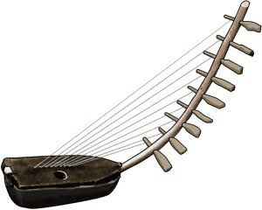

**Soundboard**

* It amplifies sound

**Soundhole**

* It amplifies sound
* It resonates with the tones
* It enhances the tone quality

**A diagram showing a tube fiddle**

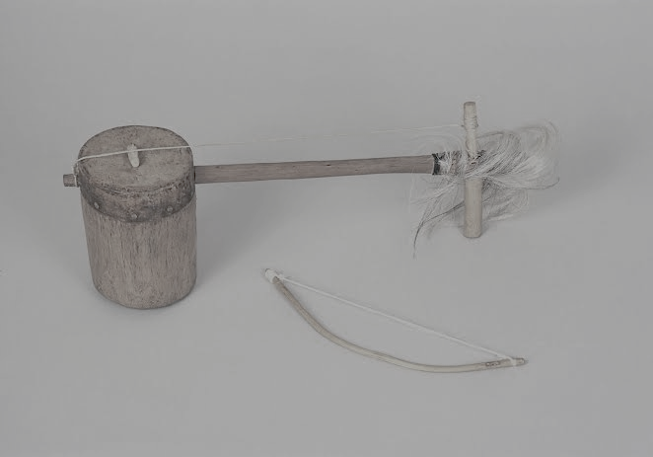

**String**

* It vibrates to produce sound when plucked

**Knob**

* For changing the tension of the string

**OR**

* For tightening or loosening the string

**Bridge**

* It supports the string
* It transmits sound vibration from the string to the soundboard

**Soundboard**

* It amplifies sound

**CHANGING PITCH OF STRING MUSICAL INSTRUMENTS**

* By tightening or loosening the strings
* By shortening or lengthening the strings

**Increasing the pitch of string musical instruments**

* By tightening the strings
* By shortening the strings

**Reducing the pitch of string musical instruments**

* By loosening the strings
* By lengthening the strings

**PERCUSSION INSTRUMENTS**

These are instruments that produce sound by vibration of their surface when hit or struck or shaken or beaten.

**Examples of percussion instruments**

* Marimba
* Xylophone (balafon)
* Vibraphone
* Drum
* Long drum
* Thumb piano
* Piano
* Shakers
* Cymbals
* Shakers
* Rattles
* Timpani
* Castanet
* Triangle
* Bell
* Maracas
* Tambourine
* Gong
* Celesta

**Diagrams showing some percussion instruments.**

Drum Xylophone Long drum Bell

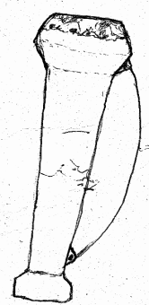

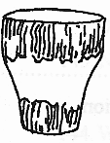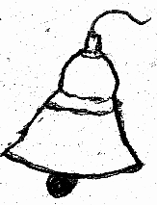

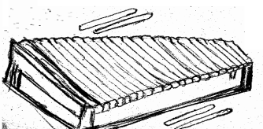

**How do the following percussion instruments produce sound?**

**Piano**

* By vibration when its own hammer hits the strings

**Shaker**

* By vibration of the objects inside it and its skin when shaken

**Drum**

* By vibration of its skin when beaten or hit

**Xylophone**

* By vibration of its wooden keys when struck with mallets

**CHANGING THE PITCH OF SOUND PRODUCED BY PERCUSSION INSTRUMENTS**

* By reducing or increasing the size of vibrating surface
* By tightening or loosening the vibrating surface

**INCREASING THE PITCH OF SOUND PRODUCED BY PERCUSSION INSTRUMENTS**

* By reducing the size of the vibrating surface
* By tightening the vibrating surface

**Of what importance are the strings on the sides of the drum?**

* To keep the skin tight

**WIND INSTRUMENTS (AEROPHONES)**

These are instruments which produce sound by vibration of air blown inside them

**Examples of wind musical instruments**

* Whistle
* Oboe
* Trumpet
* Panpipes
* Flute
* Saxophone
* Bugle
* Clarinet
* Horn
* Vuvuzela
* Saxophone
* Tuba
* Trombone

**Diagrams showing panpipes, horn, whistle and flute**

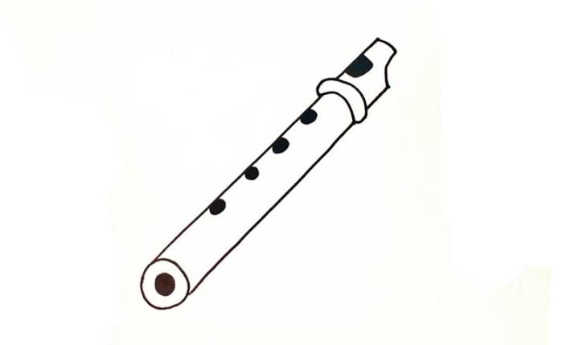

**How can the pitch of wind musical instruments be increased?**

* By reducing the vibrating space (making the vibrating space smaller)

**How can the pitch of wind musical instruments be decreased?**

* By increasing the vibrating space (making the vibrating space bigger)

**TRANSMISSION OF SOUND**

This is the movement of sound waves from one place to another

**How does sound travel?**

* Through sound waves

**PROPERTIES OF SOUND**

* It travels in all directions from the source
* It can be reflected
* It can be refracted
* It cannot travel through vacuum

**MEDIUM OF SOUND**

This is a material through which sound is transmitted

**MEDIA THROUGH WHICH SOUND TRAVELS**

* Solid
* Liquid
* Gas

**What enables sound to travel different media (states of matter)?**

* Molecules

**VACUUM**

* This is the space without matter

**Why is sound unable to travel through vacuum?**

* There is no matter (molecules)

**SPEED OF SOUND IN DIFFERENT MEDIA**

|  |  |
| --- | --- |
| **MEDIUM (STATE OF MATTER)** | **SPEED OF SOUND** |
| Gas (air) | 330m/s |
| Liquid (water) | 1500m/s |
| Solid (iron) | 5000m/s |

* **Sound travels slowest in gases**

Molecules are farthest apart (very loosely packed)

* **Sound travels faster in liquids**

Molecules in liquids are close together

* **Sound travels fastest in solids**

Molecules are tightly packed

**Why does sound travel fastest through solids?**

* Molecules in solids are tightly packed (closest together)

**Why does sound travel faster in water (liquids) than in air (gases)?**

* Molecules in water are closer together than those in air

**FACTORS AFFECTING THE SPEED OF SOUND**

* Temperature
* Wind
* Altitude
* Humidity
* Heat

**Temperature**

When temperature is low, sound waves are nearer the ground and when temperature is high, sound waves raise above the ground.

**Why is sound heard clearly at night than during day time?**

* At night, temperature is low and sound waves travel nearer the ground during day time

**Wind**

Sound waves travel faster when they are in the same direction with wind and sound waves travel slowly when they are in opposite direction with wind

**Altitude**

Low altitude increases the speed of sound and high altitude reduces the speed of sound

**Heat**

Heat of the day raises sound waves higher

**PITCH, FREQUENCY AND VOLUME OF SOUND**

**Pitch**

This is the highness or lowness of sound

**Factors that determine the pitch of sound**

* **Size of the vibrating surface**

Small surfaces produce high pitch while big surfaces produce low pitch

* **Tension of the vibrating surface**

Tight surfaces produce high pitch while loose surfaces produce low pitch

* **Frequency**

High frequency produces high pitch while low frequency produces low pitch

* **Nature of the vibrating surface**

Thin surfaces produce high pitch while thick surfaces produce low pitch

* **Length of the vibrating surface**

Short vibrating surfaces have high pitch while long vibrating surfaces have low pitch

**EXPERIMENTS ON PITCH OF DIFFERENT OBJECTS**

**Bottles**

Bottle A will produce the highest pitch

* It has the smallest vibrating space

Bottle B will produce the higher pitch

* It has the bigger vibrating space

Bottle C will produce the lowest pitch

* It has the biggest vibrating space

**Why does an empty bottle produce lower pitch than a bottle half filled with water?**

It has a bigger vibrating space than a bottle half filled with water

**Drums**

Drum 1 will produce the lowest pitch

* It has the biggest vibrating surface

Drum 2 will produce the lower pitch

* It has the smaller vibrating surface

Drum 3 will produce the highest pitch

* It has the smallest vibrating surface

**Bow harp**

String X will produce the lowest pitch

* It has the longest vibrating surface

String C will produce the highest pitch

* It has the shortest vibrating surface

**Flute**

When holes A and B are closed, a flute produces the highest pitch

* The vibrating space will be very big

When holes B and C are closed, a flute produces the lowest pitch

* The vibrating space will be very small

**How is a flute played?**

* By opening or closing one or more holes with the fingers while blowing

**Frequency**

This is the number of vibrations produced per second

This is the number of oscillations per second

**Units for measuring frequency**

* Hertz (Hz)

**Factors that determine frequency (f) of sound**

* Mass of the object
* Force that shakes the object

**A diagram showing a sound wave**

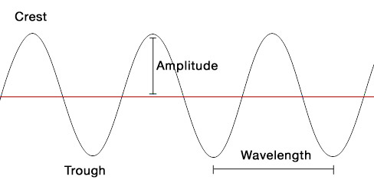

Rest point

**Wave length**

This is the distance between two consecutive crests or troughs

**Drawings showing sound waves of different frequency and pitch**

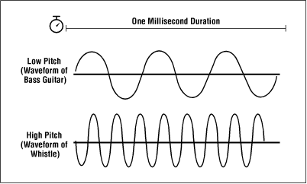

Wave P

Wave Q

Sound wave P will produce sound with low frequency and low pitch

* It is slow

Sound wave Q will produce sound with high frequency and high pitch

* It is quick

**VOLUME**

This is the loudness or softness of sound

This is the magnitude or intensity of a certain sound

**FACTOR AFFECTING VOLUME OF SOUND**

* **Amplitude**

This is the height of the wave from the point of rest

This is the height of sound vibrations

Great amplitude forms loud sound while small amplitude forms soft sound

**ECHO**

* An echo is a reflected sound

**How is an echo formed?**

* By obstruction of sound waves (when sound waves hit a hard surface)

**Echolocation**

* This is the ability of an organism to locate objects using echoes.

**Mention three animals that use echolocation**

* Bats
* Dolphins
* Whales
* Porpoises

**Importance of echoes**

* They help bats and whales to dodge obstacles
* They help bats and whales to locate their food
* They help sailors to detect the depth of the water body
* They help fishermen to locate shoals of fish
* They help pilots to dodge tall buildings and mountains.
* They help blind people to dodge obstacles using sonar sticks
* They help doctors to detect heart beat

**Disadvantages of echoes**

* They turn music into noise in empty room
* They prevent people from communicating clearly

**How can echoes be reduced in cinema halls, recording studios, conference halls and theatre halls?**

* Covering the walls with soft boards
* Covering the walls with sponge and thick blankets
* Covering the windows with thick curtains
* Covering the floor with woollen carpets

**Sound absorbers**

These are materials that absorb sound waves

**Characteristics of sound absorbers**

* They are soft
* They are porous

**Examples of sound absorbers (materials that reduce echoes)**

* Thick blankets
* Thick curtains
* Woollen carpets
* Soft boards
* Sponge

**How do soft porous materials (e.g soft boards) prevent echoes?**

* They absorb sound waves

**Mention any two devices that use echoes to work**

* **Fathometer**

It is used to measure the depth of seas and oceans

* **Stethoscope**

It is used to detect heart beat

**Mention four groups of people who use echoes**

* Pilots
* Sailors
* Doctors
* Fishermen

**Why do we see lightning before thunder is heard during thunderstorm?**

* Light travels faster than sound in air

**CALCULATIONS ON SOUND**

Speed of sound in air is 330 m/s

**Examples**

**1**. If a man heard a gunshot after four seconds, how far was he from the firing point?

(Take; speed of sound in air = 330 m/s)

**D = S x T**

**D = 330 m/s x 4 s**

**D = (330 x 4) m**

**D = 1320 m**

**2.** Mutaawe shouted while facing a cliff and it took him 10 seconds to hear the echo of the sound he produced. How far was he from the cliff if the speed of sound is 330m/s?

**Sound moved two journeys 9Going to the cliff and coming back from the cliff to Mutaawe)**

**D = S x T**

**2**

**D = 330 x 10**

**2**

**D = 3300**

**2**

**D = 1650 metres**

**3**. It took 3 seconds to hear echo of a man chopping wood. How far was the man from a chopping place?

**There are two sets of sound waves (original waves and the reflected waves)**

**D = S x T**

**2**

**D = (330 x 3)**

**2**

**D = 990**

**2**

**D = 495m**

1. A cliff is 660m away from where Kato is standing. If Kato blows a whistle, how long will it take him to hear the echo if the speed of sound is 330 m/s?

Sound moves two journeys

**T = ( D x 2)**

**S**

**2**

**T = 660 x 2**

**330**

**T = 2 x 2**

**T = 4 seconds**

**Try this**

Okello was standing 165 metres away from his father who called him by clapping. How long did it take Okello to hear the clapping?

**T = D**

**S**

**T = 165**

**330**

**T = 0.5 seconds**

**STORAGE OF SOUND**

This is the act of keeping sound for future use

**Reasons for storing sound (Why do people store sound?)**

* For entertainment
* For communication
* For remembrance
* For evidence in courts of law

**METHODS OF STORING SOUND**

* Recording method
* Notation method

**NOTATION METHOD**

This is the act of storing sound by writing musical symbols or notes

**Types of notation**

**Sol-fa notation**

This is the use of octaves (musical notes) to store sound

**Staff notation**

This is the use of musical symbols marked on parallel lines to store sound

**How to reproduce sound stored by notation**

* Using a piano to play sound notes
* Using human voice to sing sound notes

**RECORDING OF SOUND**

This is the act of making an audio record

**Devices used to store recorded sound**

* Memory cards
* Video Compact Discs (VCDs)
* Digital Video Discs (DVDs)
* Magnetic tapes (cassette tapes)
* Computer diskettes
* Projectors
* Mobile phones
* Flash drive
* Compact discs (CDs)
* Audio tapes
* IPods
* Computer hard disks
* Records

**Devices used to reproduce recorded sound**

* record players (phonograph)
* Cassette players
* Film projectors
* DVD players
* VCD players
* Computers
* Mobile phones
* Gramophone
* Mp3 player

**Ways of reproducing recorded sound**

* By playing records in record players
* By playing cassette tapes in cassette players
* By playing CDs in CD players
* By playing VCDs in VCD players
* By playing DVDs in DVD players
* By playing mp3 in mp3 players
* By playing flash discs in computers
* By playing memory cards in mobile phones

**THE MAMMALIAN EAR**

* It is a sense organ for hearing
* It is a receptor organ for sound
* The ear belongs to the **nervous system**

**MAIN FUNCTIONS OF THE MAMMALIAN EAR**

* For hearing
* For body balance

**Besides hearing and body balance, how else are ears useful to an elephant?**

* To regulate the body temperature on hot days

**How are ears important to a deaf person?**

* For body balance

**REGIONS (MAIN PARTS) OF THE MAMMALIAN EAR**

* Outer ear
* Middle ear
* Inner ear

**THE OUTER EAR**

It is a hollow region

**Parts that make up the outer ear**

* Pinna
* Auditory canal (ear canal)

**THE MIDDLE EAR**

It is an air-filled region

**Parts that make up the middle ear**

* Ear drum (tympanic membrane)
* Ossicles
* Eustachian tube
* Oval window

**THE INNER EAR (LABYRINTH)**

It is a fluid-filled region

**Parts that make up the inner ear**

* Semicircular canals
* Cochlea
* Auditory nerves

**THE STRUCTURE OF THE HUMAN EAR**

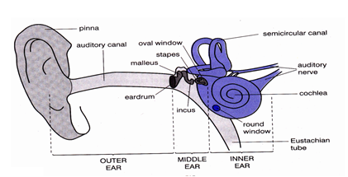

**FUNCTIONS OF EACH PART OF THE HUMAN EAR**

**PINNA**

* It traps (collects) sound waves
* it receives and concentrates sound waves

**How is the pinna adapted to its function?**

* It is large and broad

**How is the pinna able to keep open all the time?**

* It is made up of cartilage

**AUDITORY CANAL (EAR CANAL)**

* It directs sound waves to the ear drum

**Components of the auditory canal**

**Earwax (cerumen)**

* To trap foreign bodies (dust and small insects)
* To kill bacteria in the ear canal

**Cilia (tiny hair)**

* It traps dust

**EAR DRUM (TYMPANIC MEMBRANE)**

* It changes sound waves to sound vibrations
* It separates outer ear and the middle ear

An **otoscope** is an instrument used to examine the ear drum

**How is the ear drum adapted to its function?**

* It has a thin membrane which is sensitive to sound waves

**OSSICLES**

These are the three small bones in the middle ear.

* They amplify sound (sound vibrations)
* They transmit sound vibrations to the oval window

**Name the three small bones that make up the ear ossicles**

* Malleus (Hammer)
* Incus (Anvil)
* Stapes (Stirrup)

The **stapes** is the smallest bone in the human skeleton

**OVAL WINDOW**

* It transmits sound vibrations to the cochlea

**ROUND WINDOW**

* It balances air pressure in the cochlea

**EUSTACHIAN TUBE**

This is a tube that connects the middle ear to the back of the throat

* It balances air pressure on both sides of the ear drum
* It drains a fluid from the middle ear to the back of the nose (throat)

**SEMICIRCULAR CANALS**

* It maintains body balance/posture

**Explain the meaning of the following terms:**

**Posture**

* This is the position of the body in everything we do

**Body balance**

* This is the ability of the body to keep upright

**COCHLEA**

This is a snail/spiral- shaped part of the inner ear

* It changes sound vibrations to nerve signals/impulses

**How is the cochlea adapted to its function?**

* It has hair cells (sensory cells)

**Which part of the human ear is greatly affected by alcohol?**

* Cochlea

**Name the two fluids in the inner ear (cochlear fluids)**

* Perilymph
* Endolymph

**AUDITORY NERVE (COCHLEAR NERVE)**

* It transmits sound information to the brain

OR

* It transmits nerve signals to the brain

**VESTIBULAR NERVE**

* It transmits balance information to the brain

**State the importance of the vestibulocochlear nerve in the human ear**

* It transmits sound and balance information to the brain

**Why do nerve (neural) signals go to the brain?**

* For interpretation

**Name two parts of the human ear that maintains body balance**

* Semicircular canals
* Vestibule

**Mention three body organs that maintain body balance**

* Ears
* Brain
* Eyes

**COMMON DISEASES OF THE EAR**

* Otitis
* Otomycosis

It is a fungal disease

* Ear boils (furuncle)

It is a bacterial disease

* Barotrauma

It is due to change in altitude (air or water pressure)

* Cancer of the outer ear

It is due to excessive exposure of ears to direct sunshine

**OTITIS**

It is grouped into;

* Otitis externa (swimmer’s ear) due frequent moisture in ear canal
* Otitis media
* Otitis interna

**SYMPTOMS OF INFECTED EARS**

* Ringing in the ear (tinnitus)
* Dizziness (problems with body balance)
* Ear pain (earache)
* Mild hearing loss

**SIGN OF INFECTED EARS**

* Pus discharge from the ears

**EAR DEFECTS (DISORDERS OF THE HUMAN EAR)**

* Permanent deafness
* Partial deafness
* Sensory deafness
* Anotia

**DEAFNESS (HEARING LOSS)**

This is the partial or total inability to hear

**TYPES OF DEAFNESS**

**Permanent deafness**

This is the inability to hear any sound

**Causes of permanent deafness**

* It can be inherited from parents
* Broken (ruptured) eardrum
* Infections like German measles (Rubella)

**Temporary (partial) deafness**

This is the inability to hear properly

**Causes of temporary deafness**

* Excess earwax (earwax impaction)
* Exposing ears to very loud sounds
* A lot of dust in the ear canal

**How does excess ear wax cause temporary deafness?**

* It blocks the ear canal

**Sensory deafness**

This is inability to distinguish some sounds

In babies, it even affects the ability to talk normally

**Causes of sensory deafness**

* Damage on the auditory nerve
* Damage on the hair cells in the cochlea
* Head injury (a blow to the head)
* Ototoxic drugs
* Old age

**What do we call the sensory deafness where a person is unable to hear high-pitched sound?**

* Presbycusis

It affects people above the age of 65

It occurs due to **old age (aging)**

**Anotia**

This is the congenital deformity where a person has no pinna.

**METHODS USED DURING COMMUNICATION WITH DEAF PEOPLE**

* Sign language
* Lip-reading
* Cued speech
* Typed conversations

**CARE FOR THE EAR**

* Wash the ears with clean warm water and soap
* Do not push sharp objects into the ear.
* Avoid very loud sound
* Use a clean soft cloth to clean the ears
* Treat any ear infection as soon as possible
* By immunization

**Why is it not advisable to push sharp objects in our ears?**

* They may damage (rupture) the eardrum.

**What first aid can be given to a person with a small insect in the ear?**

* Pour clean cold water in the ear to make the insect come out

**HEARING IN DIFFERENT ORGANISMS**

**Mammals (people)**

* By means of ears

**Birds**

* By means of ears covered with soft feathers

**Fish**

* A fish uses lateral line to detect sound vibrations in water

**Insects**

* By means of antennae/feelers

**Snakes**

* They use their skull vibration when hit by sound waves in the air
* They use their jawbone connected to the cochlea to detect ground vibrations

**Earthworms**

* By means of their entire body

**Snails**

* By means of tentacles

**THEME: THE HUMAN BODY**

**TOPIC: THE CIRCULATORY SYSTEM**

**Cell**

This is the smallest unit of life

**Tissue**

This is ta group cells that work together to perform a specific function

**Organ**

This is a group of tissues that work together to perform a specific function

**System**

This is a group of organs that work together to perform a specific function

**THE CIRCULATORY SYSTEM**

* This is the body system that deals with transporting of materials in the body

**OR**

* This is the body system that deals with the movement of blood round the body

**Materials transported in the body**

* Water

Useful materials

* Hormones
* Oxygen
* Food nutrients
* Antibodies
* Urea

Harmful materials

* Carbon dioxide
* Poison

**BLOOD CIRCULATION**

* This is the movement of blood round the body

Blood circulation was discovered by an English scientist known as **Sir. William Harvey**

**Importance of blood circulation in the body**

* It transports food and oxygen in the body
* It transports hormones in the body
* It transports wastes products to excretory organs

**TYPES OF BLOOD CIRCULATION**

* Pulmonary circulation
* Systemic circulation

**Pulmonary circulation**

* This is movement of blood from the heart to the lungs and back to the heart

**Systemic circulation**

* This is the movement of blood from the heart to the other body parts

**COMPONENTS OF CIRCULATORY SYSTEM**

* Heart
* Blood vessels
* Blood

**THE HEART**

Heart is a muscular organ that pumps blood in the body of a vertebrate

* It is located in the **chest cavity** between the lungs
* It is protected by the **rib cage**
* It is made up of special muscles called **cardiac muscles**
* It is enclosed in a serous membrane called **pericardium**
* **Pericardium** produces a fluid that lubricates the heart (produces pericardial fluid)
* **Pericardial fluid** lubricates the heart (reduces friction during heartbeat)
* **Coronary artery** supplies food nutrients and oxygen to the heart muscles.

**Main function of the heart**

* To pump blood in the body

The heart pumps about **5 litres of blood per minute**

**PULSE**

This is the number of times the heart beats per minute

* The normal heartbeat of an adult person at rest is **72 beats per minute**

**Heartbeat**

This is the contraction and relaxation of the heart

**Factors that can increase heartbeat or pulse**

* Excitement
* Fright
* Physical exercises
* High temperature
* Sickness
* Increased level of adrenaline hormone

Adrenaline hormone prepares the body for a flight or fight

**Why does the heart beat faster when doing a heavy body exercise?**

* To pump more oxygenated blood to the body tissues

**Note**

**Stethoscope** is used to detect heartbeat/pulse

**Sphygmomanometer** is used to measure blood pressure

**A diagram showing a stethoscope**

It has a diaphragm, long rubber tube and two earpieces

**PHASES OF HEART BEAT (CARDIAC CYCLE)**

* **Systole phase**

This is contraction of the ventricles to push blood into the arteries.

During this phase, the auricles are filled with blood

* **Diastole phase**

This is contraction of auricles to push blood into the ventricles

During this phase, the ventricles are filled with blood

**THE STRUCTURE OF THE HUMAN HEART**

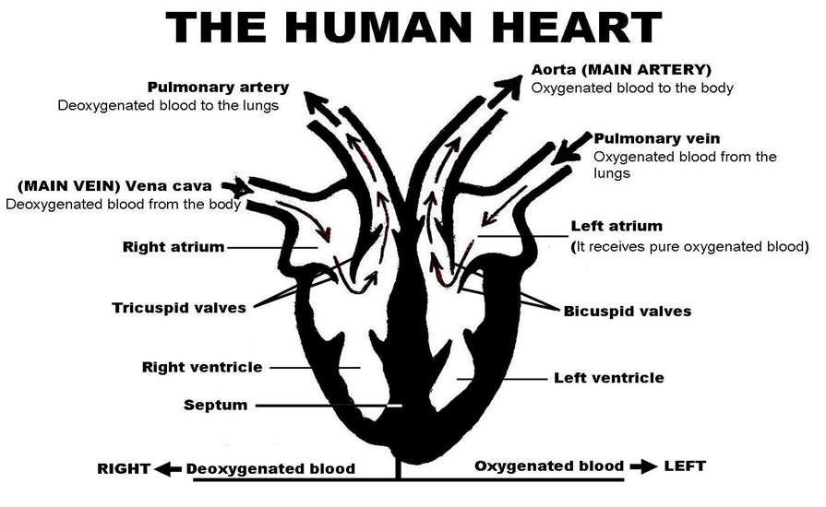

**(mitral valves)**

The mammalian heart has 4 chambers

* Right auricle
* Left auricle
* Right ventricle
* Left ventricle
* The upper chambers are called **atria (auricles)**
* **Auricles** receive blood
* The lower chambers are called **ventricles**
* **Ventricles** pump blood out of the heart
* The left and right sides of the heart are separated by a thick wall called **septum**

**FUNCTIONS OF EACH PART OF THE HEART**

* **Vena cava**

It carries deoxygenated blood from all body parts to the heart

The **vena cava** is the largest vein in the body

* **Right auricle**

It receives deoxygenated blood from the body parts

* **Right ventricle**

It pumps deoxygenated blood to the lungs

* **Pulmonary artery**

It carries deoxygenated blood from heart to lungs

**Why does blood go to the lungs?**

* To pick oxygen (to be oxygenated)
* To drop carbon dioxide (to get rid of carbon dioxide)
* **Pulmonary vein**

It carries oxygenated blood from lungs to heart

* **Left auricle**

It receives oxygenated blood from the lungs

* **Left ventricle**

It pumps oxygenated blood to all body parts

* **Aorta**

It carries oxygenated blood from the heart to all body parts

The **aorta** is the largest artery in the body

* **Septum**

It prevents mixing of oxygenated blood and deoxygenated blood

* **Valves**

They prevent the back flow of blood

**Why is the left ventricle thicker walled than the right ventricle?**

* It pumps blood at a higher pressure than the right ventricle

**BODY ORGANS RELATED TO BLOOD CIRCULATION**

**Kidneys**

* They filter blood (they purify blood)

**Liver**

* It regulates blood sugar level
* It detoxicates blood

**Lungs**

* They oxygenate blood
* They remove carbon dioxide from blood

**State the importance of the hepatic portal vein**

* It carries blood with digested food from the ileum to the liver

**THE DIAGRAM TO SHOW CIRCULATION OF BLOOD**

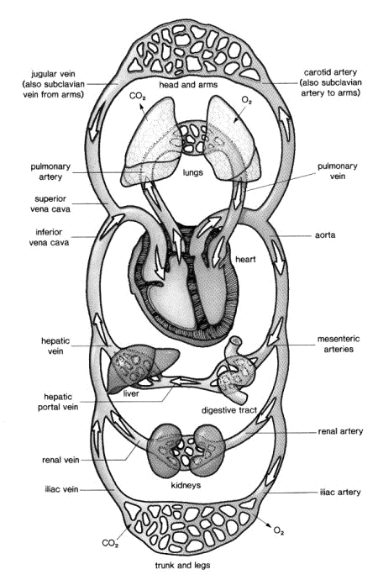

**BLOOD VESSELS**

* These are tubes that transport blood in the body

**Types of blood vessels**

* Arteries
* Veins
* Capillaries

**ARTERIES**

These are blood vessels that carry blood away from the heart

* The main (largest) artery is the **aorta**
* Most arteries carry oxygenated blood **except** pulmonary artery
* Blood in arteries flows at a high pressure

**Characteristics of arteries**

* They have thick walls
* They have a narrow lumen
* They have no valves

**Function of arteries**

* They carry blood away from the heart.

**The structure of an artery**

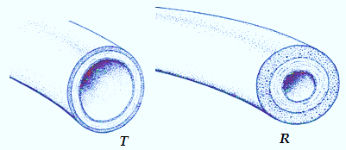

narrow lumen

thick walls

**Adaptations of arteries to their function**

* They are thick walled

To withstand the high pressure of blood that flows through them.

* They are elastic

To stretch so as to accommodate the large volume of blood that flows through them

**Why do arteries have thick walls?**

* To withstand the high pressure of blood that flows through them.

**Why do arteries lack valves?**

* They carry blood at a very high pressure

**VEINS**

These are blood vessels that carry blood to the heart

* The main (largest) vein is the **vena cava**
* Most veins carry deoxygenated blood **except** pulmonary vein
* Veins are seen near the skin surface
* **Hepatic portal vein** carries blood with digested food from the ileum to the liver

**Characteristics of veins**

* They have thin walls
* They have a wider lumen
* They have valves

**Function of veins**

* They transport blood to the heart.

**The structure of a vein**

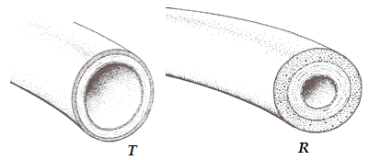

thin walls

Wider lumen

**A diagram showing the direction of flow of blood in a vein**

**Adaptations of the veins to their function**

* They are thin walled

To withstand the low blood pressure in them

* They have a wider lumen

To encourage the flow of blood

* They have valves

To prevent the back flow of blood.

**How are valves important in veins?**

* Valves prevent the back flow of blood

**Why are arteries thick walled than veins?**

* Blood in arteries flows at a higher pressure than veins

**CAPILLARIES**

These are tiny blood vessels that join arteries to veins

* Capillaries are the **smallest** blood vessels
* They connect arteries and veins
* Exchange of materials occurs in capillaries

**Characteristics of capillaries**

* They have thin walls (have porous walls)
* They have no valves

**Functions of capillaries**

* They allow exchange of materials
* They join arteries to veins

**Structure of capillaries**

**Adaptations of capillaries to exchange of body materials?**

* They are numerous (very many in number)

To increase the surface area for exchange of materials

* They have thin walls (porous walls)

For easy diffusion of materials

**DIFFERENCES BETWEEN ARTERIES AND VEINS**

|  |  |
| --- | --- |
| **ARTERIES** | **VEINS** |
| **Functional difference** | |
| They carry blood away from the heart | They carry blood towards the heart |
| **Structural difference** | |
| Have no valves | Have values |
| Have thick walls | Have thin walls |
| Have a narrow lumen | Have a wide lumen |

**BLOOD**

This is a liquid tissue that transports materials in the body

* Blood in vertebrates is **red in colour**

**Types of blood**

* **Oxygenated blood**

It is rich in oxygen and digested food

It is bright red

* **Deoxygenated blood**

It is rich in carbon dioxide and waste products

It is dark red

**COMPONENTS OF BLOOD (BLOOD CONSTITUENTS)**

* Red blood cells ( erythrocytes )
* White blood cells (leukocytes)
* Platelets ( thrombocytes)
* Plasma

**By what process are blood cells formed in the red bone marrow?**

* Haemopoiesis

**RED BLOOD CELLS**

* They are the most numerous blood cells in the body
* They are made in the **red bone marrow**

**Function of red blood cells**

* They transport oxygen in the body

**Characteristics of red blood cells (erythrocytes)**

* They have no nuclei
* They have a bi-concave shape (disc shape)
* They contain haemoglobin

**What is haemoglobin?**

* This is the red pigment found in blood
* It is an iron compound in red blood cells that transport oxygen

**Importance of haemoglobin**

* It carries oxygen
* It determines the red colour of blood

**NOTE**

* Haemoglobin combines with oxygen to form **oxyhaemoglobin**
* RBCs become **bright red** with oxygen and **dark red** when they lose oxygen

**In which form is oxygen transported in blood?**

* Oxyhaemoglobin

**Why are red blood cells red in colour?**

* Due to presence of haemoglobin

**The structure of a red blood cell**

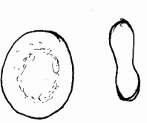

**ADAPTATIONS OF RED BLOOD CELLS TO THEIR FUNCTION**

* They have haemoglobin

To absorb (carry) oxygen

* They are numerous
* They have no nucleus

To provide enough room for oxygen

* They have a biconcave shape

To increase the surface area for diffusion of oxygen

* They have a thin membrane

To allow easy diffusion of gases

**Why do people living at higher altitudes have more RBCs?**

* There is little oxygen at higher altitudes

**Why do infants have more red blood cells than adults?**

* Infants have a higher metabolic rate than adults

**NOTE**

* **Plasmodia germs (malaria parasites)** destroy the red blood cells
* **Sickle cell anaemia (sickle cell disease)** deforms red blood cells

**WHITE BLOOD CELLS**

* WBCs are fewer than RBCs in number

**Characteristics of white blood cells**

* They have a nucleus
* They do not have a defined shape ( they have an irregular shape)
* They have no haemoglobin (so they are colourless)

**In which body parts are white blood cells made?**

* Bone marrow of long bones
* Lymph nodes
* Spleen

**Function of white blood cells**

* They defend the body against diseases (infections)

**OR**

* They fight against pathogens (disease causing germs)

**The structure of a white blood cell**

nucleus

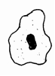

cell membrane

cytoplasm

**How do white blood cells defend the body against diseases?**

* They engulf and digest germs
* They produce antibodies

**Adaptation of a white blood cell to its functions**

* It has a nucleus to control cell activities
* It has cytoplasm to engulf germs
* It has an irregular shape to engulf germs of different shapes

**Why do children have more WBCs than adults?**

* They are more prone to disease attack than adults

**Diagrams showing how white blood cells engulf germs**

**NOTE:**

* **HIV (human immunodeficiency virus)** destroys the white blood cells
* Too much white blood cells in blood cause **leukemia (blood cancer)**

**How is pus formed?**

* When some white blood cells and germs die during the fight (decaying in the tissue)

**PLATELETS**

* These are small colourless disc shaped particles in blood
* They are made in the **red bone marrow**

**Characteristics of platelets**

* They have no nucleus
* They have a disc shape

**Function of platelets**

* They help in blood clotting in case of a cut

**How do platelets stop bleeding?**

* By forming blood clots on cuts and wounds

**An illustration showing platelets**

**NOTE**

* A hereditary disease in which a person has uncontrolled bleeding is called **haemophilia**
* Haemophiliais caused by **lack of clotting factor in blood**
* Vitamin K **helps in formation of platelets**
* Lack of vitamin K in the diet **leads to poor blood clotting**

**What health problem is a personal likely to get due to inadequate platelets in blood?**

* Excessive bleeding in case a cut/poor blood clotting

**Structure of platelets**

**BLOOD PLASMA**

This is the pale liquid component of blood

* It makes up about 55% of blood
* It is where red blood cells, white blood cells and platelets are suspended
* It consists of 90 percent water
* Plasma holds all the other blood cells

**Constituents (components) of blood plasma**

* Water
* Hormones
* Antibodies
* Digested food (glucose, amino acids, mineral salts and lipids)
* Urea

Excretory wastes

* Carbon dioxide

**Functions of blood plasma**

* It transports hormones in the body
* It distributes heat in the body
* It transports blood cells
* It transports digested food in the body (e.g glucose, lipids and amino acids)
* It transports water and mineral salts in the body
* It transports metabolic wastes to the excretory organs
* It transports antibodies in the body

**GENERAL FUNCTIONS OF BLOOD**

**Transport functions:**

* It transports digested food in the body
* It transports oxygen in the body
* It transports hormones in the body
* It transports metabolic wastes to excretory organs.

**Protective functions:**

* It protects the body against diseases
* It prevents bleeding by clotting on cuts and wounds

**Regulative function:**

* It distributes heat in the body

**How does blood help in body temperature regulation?**

* It distributes heat in the body

**BLOOD GROUPS (BLOOD TYPES)**

* Group A
* Group B
* Group AB
* Group O

Blood groups were discovered by a Scientist called **Sir Karl Landsteiner**

**How are blood groups formed?**

* According to the antigens in red blood cells

**Blood donor**

* This is a person who gives blood

**Recipient**

* This is a person who receives blood

|  |  |
| --- | --- |
| **RECIPIENT** | **BLOOD DONOR** |
| A | A and O |
| B | B and O |
| AB | A, B, AB and O |
| O | O |

**Universal recipient** is a person who receives blood from all blood groups

**Group AB** is a universal recipient

**Universal donor** is a person who gives blood to all blood groups

**Group O** is a universal donor

**WAYS OF INCREASING THE VOLUME OF BLOOD IN THE BODY**

* Feeding on food rich in iron
* Taking iron tablets
* Through blood transfusion
* Drinking plenty of fruit juices

**BLOOD TRANSFUSION**

This is the transfer of screened blood from one person to another as long as blood groups agree.

**Give one reason why blood should be screened before transfusion**

* To prevent the spread of diseases in infected blood

**BLOOD SCREENING**

This is the examining of blood under a microscope

**Importance of screening blood**

* It helps to discover the germs in blood
* It helps to discover blood groups
* It promotes safe blood transfusion

**Diseases of circulatory system**

Groups of circulatory diseases

* Diseases of blood (blood diseases)
* Diseases of the heart (heart diseases)
* Hereditary diseases

**Blood diseases**

These are diseases that affect blood components

* Malaria
* HIV/AIDS
* Sickle cell anaemia
* Anaemia
* Leukemia (blood cancer)

**Heart diseases**

* Heart attack (cardiac arrest)
* Coronary heart disease (CHD)
* Coronary thrombosis
* Hypertension ( high blood pressure)
* Hypotension (low blood pressure)

**Hereditary diseases**

* Haemophilia
* Sickle cell anaemia

**DISORDERS OF THE CIRCULATORY SYSTEM**

* Heart failure
* Hardening of the arteries (arteriosclerosis)
* Defective cells
* Blood clot
* Cuts and wounds

**PREVENTION AND CONTROL OF THE CIRCULATORY DISEASES**

* Feeding on a balanced diet.
* Eat very low animal fats
* Perform regular body exercises.
* Avoid much alcohol.
* Avoid smoking
* Have regular health checkups

**Importance of physical exercises to the body**

* It makes the heart muscles to grow stronger and larger
* It reduces body weight (it controls obesity)
* It prevents heart attack
* It makes the joints to become more flexible
* It makes the body physically fit
* It eases food digestion
* It helps the heart to pump more blood to the muscles
* It prevents sprains and strains
* It breaks fatigue (body weakness)

**AIDS**

**AIDS** stands for **Acquired Immune Deficiency Syndrome**

* **Acquired** means **to get from**
* **Immune** means **protected against**
* **Deficiency** means **lack of/shortage of.**
* **Syndrome** means **a group of signs and symptoms of a disease**.

**What causes AIDS**

* **HIV**

**HIV** stands for **human immunodeficiency Virus**

It mainly affects the **circulatory system**

HIV can only survive in the human body.

**Why can't mosquitoes spread HIV/AIDS yet they feed on blood?**

* HIV is destroyed by the enzymes in the digestive system of a mosquito
* HIV is destroyed in the body of a mosquito

**Mode of transmission of HIV/AIDS**

**(how does HIV/AIDS spread)**

* Through playing unprotected sex with an infected person
* Through infected blood transfusion
* Through sharing sharp instruments with an infected person
* From an infected mother to a newly born baby at birth
* From the infected mother to the baby through breast feeding

**Reasons why people go for HIV test before marriage**

* To know your HIV status
* To prevent the spread of AIDS
* To prevent marriage in case one person is HIV positive

**HIV STATUS**

**HIV negative (HIV –ve)**

It means that a person does not have HIV

**HIV positive (HIV +ve)**

It means that a person has HIV

**What is the difference between HIV positive person and AIDS patient?**

* HIV positive person has not yet developed signs and symptoms while AIDS patient has developed the signs and symptoms.

**Examples of body fluids in which HIV can be found**

* Blood
* Semen
* Vaginal fluids
* Breast milk

**Give any two ways in which AIDS virus (HIV) cannot spread:**

* Normal shaking of hands with AIDS patients
* Caring for AIDS patients
* Sharing cooking utensils with AIDS patients
* Touching AIDS patients
* Hugging AIDS patients
* Sitting close to AIDS patients
* Washing clothes of AIDS patients

**Why can't HIV/AIDS spread through the practices mentioned above?**

* There is no mixing of blood.
* Mosquito bites

**Why?**

* HIV is destroyed in the body of a mosquito

**Practices that increase the spread of AIDS**

**Qn. Give four bad habits that can lead to HIV transmission**

* Sharing of wives
* Inheriting of wives/widows
* Massive circumcision using one knife
* Tribal tattooing
* Blood pacts
* Polygamy
* Communal jigger extraction
* Tribal tooth extraction
* Ear and nose piercing
* Infected blood transfusion
* Prostitution
* Extra marital sex
* Pre marital sex
* Having unprotected sex with untrusted partner

**Groups of people at a high risk of getting AIDS**

* Sex workers (prostitutes)

They have many sexual partners

They play sex with many people

* Bar maids

They can be forced into sex by drunkards

* People between 15 – 45 years

They are sexually more active

* Long distance travellers e.g drivers

They play casual sex since they take long time to see their sex partners

* Medical workers who look after AIDS patients
* Night disco goers
* Regular drug abusers.
* Adolescent girls.

They are sexually attractive

**Reasons why female adolescents are at a higher risk of getting AIDS than males.**

* They mature faster than males
* They are more attracted by material goods (money) than males
* They are more vulnerable to rape and defilement
* They are more sexually attractive than males

**Reason why women are at a high risk of getting AIDS than men?**

* They are more sexually attractive than men

**Signs and symptoms of HIV/AIDS**

The incubation period of AIDS is between 1 to 10 years

**What is incubation period of a disease?**

This is the time taken from exposure to the disease causing germ until the first signs and symptoms appear.

Both AIDS patient and HIV positive person can spread the virus.

**Signs of HIV/AIDS**

* Herpes zoster
* Rapid weight loss
* Skin rash
* Severe night sweats (severe sweating at night)
* Oral thrush (white coating in the mouth)
* Chronic dry cough
* Chronic diarrhoea

**Symptoms of HIV/AIDS**

* General body weakness
* Chronic fever
* Loss of appetite

**Conditions mistaken for AIDS**

* Alcoholism
* Malnutrition

**Diseases mistaken for AIDS**

* Tuberculosis
* Typhoid
* Measles
* Skin cancer

**Effects of HIV/AIDS to the:**

**1. Individual**

* Loss of immunity
* Restriction in movement to some countries
* It causes much worry
* Loss of income
* It leads to death

**2. Family**

* It leads to poverty in a family
* It reduces family labour force
* It leads to divorce
* It increases orphans
* Family members are isolated or stigmatized in the community

**3. Community**

* It reduces the population
* Loss of important/skilled people
* Reduction in labour force
* Increased child headed families

**Prevention and control of HIV/AIDS**

* Having one faithful sexual partner
* Abstain from sex until marriage
* Avoid sharing skin piercing objects like needles with an infected person.
* Use of condoms during sex
* Women having HIV should avoid getting pregnant
* Screening blood before transfusion
* Sterilizing medical instruments before use.

**NOTE:**

**P.M.T.C.T** means **Prevention of mother to Child Transmission of AIDS**

**How to prevent mother to child transmission of HIV**

* Taking ARVs during pregnancy
* Giving birth from hospitals
* Practising bottle feeding

**How can we care and support AIDS patients**

* Feeding them on a balanced diet
* Counselling them
* Advising them to promote personal hygiene
* Advising them to take their drugs
* Giving them company

**COUNSELLING**

This is the special communication given to patients.

**Importance of counselling AIDS patients.**

* It prevents suicide
* It prevents patients from spreading the disease knowingly.
* It enables patients to live longer and useful.
* Itenables patients to overcome fear

**Types of counselling**

* Pre-HIV antibody test counselling
* Post-HIV antibody test counselling
* Counselling AIDS patients
* Counselling children with AIDS

**Note:**

**ARVs** stand for **Antiretroviral drugs**

**Organisations in Uganda that offer counselling services**

* **TASO (**The AIDS Support Organisation): It provides food supplements for AIDS patients.
* **AIC (**AIDS Information Centre)
* **ACP (**AIDS Control Programme): It also provides HIV testing.
* Uganda Cares

**AIDS does not kill. What kills?**

* The opportunistic infections

**SECONDARY infections (OPPORTUNISTIC inofections)**

These are infections a person gets due to weakened immune system.

**Examples of opportunistic (secondary) infections**

* Tuberculosis
* Pneumonia
* Meningitis

**Ways of controlling the spread of secondary infections**

* Abstain from sex until marriage
* Be faithful to your sexual partner
* Use condoms to play sex with untrusted partner
* Avoid sharing sharp skin cutting objects with infected person
* Avoid extra marital sex
* Learning more facts about HIV
* Avoid practices that can lead to easy spread of AIDS

**URINARY TRACT INFECTIONS (UTIs)**

These are diseases which affect the passage of urine

**Examples of Urinary Tract Infections (UTIs)**

* Genital warts
* Genital herpes
* Gonorrhoea
* Candidiasis
* Trichomoniasis
* Chlamydia

**Signs of UTIs**

* Blocked urethra
* Pus discharge from penis and vagina
* Swelling of the genital parts
* Bleeding from the genital parts

**Symptoms of UTIs**

* Painful urination
* Itching of genital parts

**PID**

Pelvic Inflammatory Diseases

They affect the abdominal and pelvic areas

**Signs of PID in females**

* Pain in the lower abdomen
* Fever

**Dangers of PIDs (effects of untreated STDs in females)**

* Painful menstruation
* Sterility (barrenness)
* Blocked oviducts
* Wounds in the uterus

**GENERAL PREVENTION AND CONTROL OF STDs/STIs/VDs**

* Abstain from sex until marriage
* Be faithful to your sexual partner
* Use condoms in case of having sex with untrusted partner
* Keep the reproductive organs clean
* Keep latrines clean

**LIFE SKILLS TO SAFEGUARD AGAINST STDS**

* Peer resistance
* Self awareness
* Self esteem
* Assertiveness
* Critical and creative thinking
* Decision making

**PIASCY MESSAGES ABOUT ADOLESCENCE AND REPRODUCTIVE HEALTH**

**PIASCY**

This is a programme that promotes AIDS awareness to the youths

**What does “PIASCY” stand for?**

* Presidential Initiative on AIDS Strategy for Communication to Youth

**Founder of PIASCY**

* H.E Yoweri Kaguta Museveni (in 2002)

**Reason**

* To improve communication on AIDS to youth
* To help the youths stay safe from AIDS
* To promote AIDS awareness among youth

**Importance of PIASCY messages**

* They control the spread of AIDS
* They promote care for AIDS patients
* They prevent early marriages
* They prevent teenage pregnancy.
* They promote AIDS awareness among youths
* They help children to keep their reproductive systems healthy

**PIASCY messages about adolescence**

* Stay Virgin
* Follow your religion to stay safe
* Say no to sex (abstain from sex)
* Say no to early marriage
* Avoid gifts for sex
* Have few sex partners to stay safe
* Be faithful to your sex partner
* Condom use by adults prevents AIDS
* Avoid bad touches
* Choose to delay sex
* Using violence to get sex is wrong
* Virginity is healthy
* Early sex affects my reproductive system
* AIDS kills
* AIDS has no cure
* Choose to delay sex
* HIV damages the body’s immune system
* Avoid risks to stay safe
* Testing for HIV
* Body changes at puberty are not signs to start sex
* Learn how AIDS is transmitted
* Say no to gifts for sex
* Using violence to get sex is wrong
* Avoid dark corners
* Premarital sex is risky
* People with HIV need care and support

**TOPIC: ALCOHOL, SMOKING AND DRUGS IN THE SOCIETY**

**ALCOHOL**

Alcohol is a liquid substance that makes people drunk if taken in the body in excess.

**TYPES OF ALCOHOL**

* Methanol (Methyl alcohol)
* Ethanol (Ethyl alcohol)

**METHANOL**

Methanol is made by **distillation**

* It is found mostly in home distilled alcohol.
* It is very dangerous and poisonous **because** it can cause blindness or death.
* It is always used in hospitals and industries
* It is used as fuel in cars and boats
* It is used to kill germs on (sterilize) medical instruments.
* It is used to clean wounds
* It is used to mix some drugs
* It is used to make paint remover

**ETHANOL**

It is the main alcohol present in alcoholic beverages

It is an addictive content in alcoholic drinks/beverages

**METHODS OF MAKING/PRODUCING ALCOHOL**

* Fermentation
* Distillation

**FERMENTATION**

This is the use of yeast to turn sugary juice into alcohol

* Fermented juice of fruits is used to make wine
* Fermented cereal grains are used to make beer

**Products during fermentation of alcohol**

* Ethanol
* Carbon dioxide

**Name the catalyst used during fermentation of alcohol**

* Yeast

**State the importance of yeast during fermentation**

* Yeast contains an enzyme that speeds up fermentation of alcohol.

**Name the enzyme in yeast that speeds up (catalyzes) fermentation**

* Zymase enzyme

**Besides yeast, name other organisms that help in fermentation**

* Bacteria (e.g in fermentation of milk)

**RAW MATERIALS USED TO MAKE FERMENTED ALCOHOLIC DRINKS**

|  |  |
| --- | --- |
| **FERMENTED ALCOHOLIC DRINKS** | **RAW MATERIALS** |
| Beer | Barley, water |
| Wine | Grapes, gooseberry |
| Tonto | Ripe bananas |
| Hard cider | Apple juice |
| Kwete | Sorghum, millet, maize, malt and boiled water |
| Malwa | Maize flour, millet, sorghum, water |
| Omuramba | Sorghum, water |

**Wineries** ferment grapes to make wine

**Breweries** ferment barley, wheat and other grains to make beer

**Why do most fermented drinks contain low level of alcohol?**

* They have a lot of water

**Distillation**

This is the process of evaporating crude alcohol and condensing its vapour to obtain pure alcohol

**Physical processes involved in distillation**

* Evaporation
* Condensation

**Besides evaporation and condensation, name other process involved in distillation**

* Heating

**Name the type of alcohol made by distillation**

* Methanol (methyl alcohol)

**A DIAGRAM SHOWING DISTILLATION METHOD OF MAKING ALCOHOL (METHANOL)**

*Alcohol vapour*

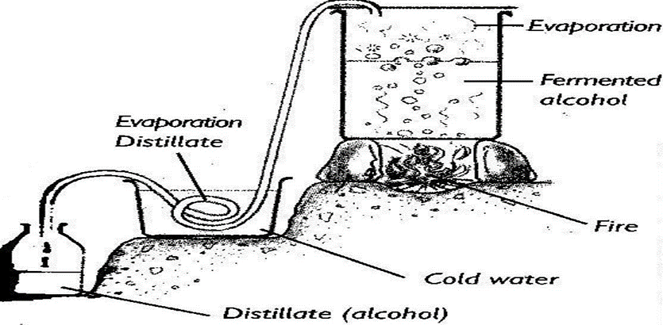

**P**

**M**

**Name the physical processes M and P**

* M is evaporation
* P is condensation

**State the importance of the cold water and heat in the process above**

**Cold water**

* To condense alcohol vapour

**Heat (fire)**

* To cause evaporation

**Name the natural process that is similar to distillation**

* Water cycle

**In which way is distillation similar to water cycle?**

* Both involve heating, evaporation and condensation

**Name two materials always used to make the delivery tube**

* Copper
* Aluminium

**Why is the delivery tube always made out of copper and aluminium?**

* They do not rust

**Why is the delivery tube passed through cold water?**

* To condense alcohol vapour

**Why is the delivery tube coiled as it is passed in cold water?**

* To increase the surface area for condensation of alcohol vapour

**What scientific name is given to the liquid substance collected by distillation?**

* Distillate

**Why does the first drop of drink collected contain more alcohol than water?**

* Alcohol has lower boiling point than water

**Give two medical uses of the distillate**

* It is used to clean wounds
* It is used to kill germs on (sterilize) medical instruments
* It is used to clean the skin before an injection

**NOTE**

The boiling point of alcohol is 780C

The boiling point of alcohol is 1000C

**EXAMPLES OF DISTILLED ALCOHOLIC DRINKS**

* Gin
* Whisky
* Waragi
* Vodka
* Brandy
* Rum
* Tequila

**Advantage of distillation**

* Alcohol collected is very concentrated

**Disadvantages of distillation**

* It can lead to burns and scalds.
* It needs much attention.

**Why is alcohol collected by distillation very concentrated?**

* It does not contain water

**USES OF ALCOHOL**

* It is used as fuel in cars and boats
* It is used to disinfect (clean) wounds.
* It is sold for money
* It is used to mix some paints
* It is used as a drink on parties.
* It is used to sterilize medical instruments (e.g clinical thermometers and surgical blades)
* It is used in six’s thermometers.
* It is used to pay dowry.
* It is used to make paint remover
* It is used to light pressure lamps.
* It is used to make some drugs in hospitals

**State the importance of alcohol in six’s thermometer**

* It is used to measure the lowest temperature of the day

**Why is alcohol used in six’s thermometer?**

* It has a very low freezing point

**REASONS WHY PEOPLE DRINK ALCOHOL**

* To pass time.
* To quench thirst
* To fit in peer groups of alcoholics
* To celebrate their success.
* To break boredom
* To show that they are rich.
* To be brave
* Young people drink to show that they are mature

**Misconceptions (myths) about alcohol**

* Alcohol improves mental performance
* Alcohol solves social problems

**Alcoholism**

Alcoholism is a condition where a person totally depends on alcohol.

**OR.**

Alcoholism is a condition that results from prolonged use of alcohol.

**Who is an alcoholic?**

This is a person addicted to alcohol.

**Addiction**

Addiction is a condition in which a person has a very strong desire to take alcohol every day.

**A drawing showing alcoholics**

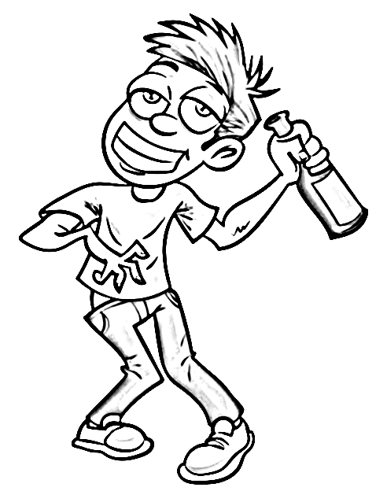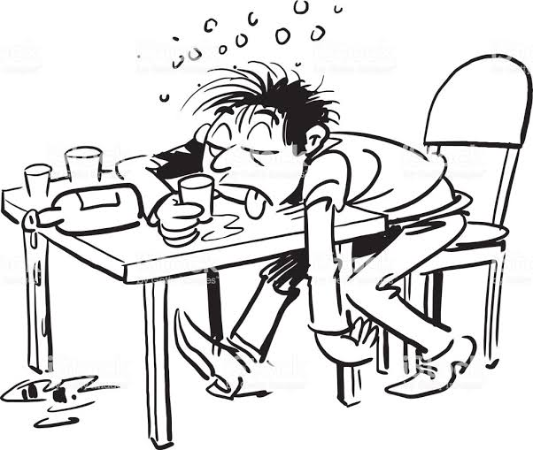

**Factors that lead to alcoholism**

* Peer pressure
* Frustration
* Family back ground
* Seductive advertisements
* Social environment

**EFFECTS OF ALCOHOLISM TO AN INDIVIDUAL**

* It leads to brain damage.
* Loss of appetite for food
* Loss of jobs
* Self-neglect
* It leads liver cirrhosis (damages the liver)
* It worsens stomach ulcers.

**Body organs affected by alcohol**

* Brain.
* Liver
* Stomach
* Pancreas
* Kidney
* Heart

**How does alcohol damage the liver?**

* It causes liver cirrhosis

**How does alcohol worsen stomach ulcers?**

* It leads to loss of appetite for food

**EFFECTS OF ALCOHOLISM TO A FAMILY**

* Family neglect
* It leads to poverty in a family
* It leads to sex deviation like incest
* It leads to domestic violence (child and spouse abuse)
* It leads to broken marriages.
* It leads to antisocial behaviour among children

**EFFECTS OF ALCOHOLISM ON THE COMMUNITY**

* It leads to truancy
* It leads to high crime rates (e.g rape, defilement and robbery)
* It increases road accidents.
* Ii increases the spread of HIV/AIDS
* It leads to loss of important people
* It leads to verbal and physical abuse (e.g quarrels and disagreements)
* Alcoholics become public nuisance.

**WAYS THROUGH WHICH THE BODY CAN REMOVE (GET RID) OF ALCOHOL**

* Through urinating
* Through sweating
* It can be burnt up by the liver.

**Give three effects of alcohol to pregnant women**

* Low birth weight
* Mental retardation of the baby
* Stunted growth of the baby
* Babies have small heads

**Immediate effects of alcohol on people**

* Slows down the action of the brain.
* Mumbling
* Double vision
* Forgetfulness
* Loss of respect for laws.
* Loss of body balance

**Long term effects of alcohol**

* Loss of appetite
* Stomach ulcers
* Liver cirrhosis
* Self-neglect
* Loss of jobs
* Swollen pancreas.
* Hand tremors (Shaking hands)

**WAYS OF AVOIDING ALCOHOLISM/HEALTH LIFESTYLES TO AVOID ALCOHOLISM**

* Avoid peer groups alcoholics
* Decide never to drink alcohol.
* Never believe in adverts that praise alcohol
* Join good social clubs (e.g sports clubs and church choir)
* Never drink alcohol to solve a problem.
* Learn more facts about dangers of alcohol.
* Take warnings about the dangers of alcohol seriously.

**LIFE SKILLS TO SAFE GUARD AGAINST ALCOHOL**

* Self-awareness
* Self esteem
* Assertiveness
* Peer resistance
* Proper decision making
* Critical thinking

**LAWS GOVERNING ALCOHOL IN UGANDA**

* All people below 18 years of age are not allowed to drink or sell alcohol in public places
* Drivers are not allowed to drink and drive: This is the **traffic law** on alcohol

To prevent road accidents

* All bars must be licensed
* Home distillation of alcohol is not allowed

It produces methanol which is poisonous (toxic)

* No one is allowed to transport or sell home distilled alcohol.

**SMOKING**

This is the inhaling of tobacco smoke

**A smoker** is a person who smokes tobacco frequently.

**Types of smoking**

**Active smoking**

This is where a person inhales smoke directly from burning cigarette or smoking pipe.

**Passive smoking**

This is where a person inhales tobacco smoke from an active smoker.

**Note**

* **Active smoker** is a person who inhales smoke directly from burning cigarette or smoking pipe.
* **Passive Smoker** is a person who inhales tobacco smoke from an active smoker.

**Dangerous drugs contained in tobacco**

* Nicotine
* Tar

**Poisonous chemicals contained in tobacco**

* Tar

**Addictive drug (substance) found in tobacco smoke**

* Nicotine

**Poisonous gases in tobacco smoke**

* Carbon monoxide
* Hydrogen cyanide

**Body organs damaged by smoking**

* Lungs
* Brain
* Mouth
* Throat

**How does nicotine affect human health?**

* It rises blood pressure
* It constricts blood vessels

**How does tar affect human health?**

* It causes lung cancer
* It makes stains on the teeth
* It causes cancer of mouth lips and throat

**Reasons why people smoke**

* To pass time/ to relax
* To concentrate on work
* To feel warm
* To fit in groups of smokers (peer influence)
* To feel confident
* To look mature
* To look attractive
* Due to attractive advertisements on radios and televisions.

**Conditions which may lead to smoking and alcoholism**

* Boredom
* Stress
* Being idle

**Factors which lead to smoking and alcoholism**

* Ignorance
* Advertisements made as regards a certain type of cigarette.
* Family background
* Peer pressure

**Effects of smoking to an individual (to the human body)**

* It causes some respiratory diseases
* It causes cancer of the mouth (lips) and throat
* It increases the risk of getting some circulatory diseases (heart attack and hypertension)
* It worsens some respiratory diseases
* It spoils the colour of teeth
* It worsens stomach ulcers
* It shortens one’s lifespan

**Respiratory diseases caused by smoking**

* Lung cancer
* Emphysema ( leads to rupture of the alveolar)
* Chronic bronchitis ( leads to difficulty in breathing and chronic cough)

**Respiratory diseases not caused by smoking**

* Asthma
* Pneumonia
* Tuberculosis

**Effects of smoking to pregnant women**

* Leads to premature births
* Leads to low birth weights
* Leads to miscarriages
* Leads to stillbirths

**Effects of smoking to the family**

* Leads to family neglect
* Family members may become passive smokers
* Leads to poverty at home
* Children may copy the habit
* Careless smokers can burn house property

**Effects of smoking to the community**

* Tobacco smoke causes discomfort to other people
* It leads to truancy among school children
* It leads to death of skilled people
* It leads to respiratory diseases among people

**How to avoid smoking**

* Do not believe in advertisements which praise cigarette smoking.
* Know that there is no good reason for smoking
* Keep away from smokers.
* Decide never to be an active smoker.
* Join good social groups like sports clubs.
* Keep yourself busy for example by reading novels.
* Destroy all things connected to smoking like cigarettes, lighter and ash trays.

**How the ministry of health helps to reduce the increased number of smokers**

* Putting a high tax on the sale of cigarettes
* Enforcing strict laws against smoking in public places
* Putting health warnings on cigarette packets.

**Lifestyles to safeguard against smoking**

* Keep away from people who smoke
* Never allow any body to convince you to smoke.
* Gather more information on dangers of smoking from health workers.
* Report your friends who smoke to the teachers or their parents for advice.
* Like games and sports during your free time.
* Never use your money to buy cigarettes.

**Withdrawal effects of nicotine (smoking)**

**Qn**. Mention two symptoms of an ex-smoker.

* Depression
* Severe sweating
* Convulsions
* Anxiety
* Restless
* Poor concentration on work
* Irritability

**Note.** The irritant substance in cigarettes is called Carcinogen.

**Ways through which people use tobacco.**

* By active smoking
* By passive smoking
* By sniffing tobacco powder in the nose
* By chewing tobacco leaves.

**DRUGS**

A drug is a chemical substance which can affect physical and mental state of the body when taken.

* It can either help or harm the body system.

**Types of drugs**

* Essential drugs
* Drugs of dependence

**ESSENTIAL DRUGS**

These are drug which satisfy people’s health needs when used properly.

**Examples of people’s health needs**

* Relieving pain
* Preventing diseases
* Stopping conception
* Adding substances in the body
* Curing diseases

**Qualities/characteristics of essential drugs**

* Should be cheap
* Should be safe to use
* Should be effective
* Should be affordable
* Should be accessible
* Should be easy to administer
* Should have important curative value

**Examples of essential drugs**

* Aspirin
* Panadol
* Iodine; for wounds
* Paracetamol; for pain and headache
* Hedex
* Coartum
* Mexaquin
* Chloroquine; for malaria fever
* Mabendazole; for deworming
* Fancida
* BCG; for tuberculosis
* ORS; for dehydration
* Cough mixtures; for cough
* Tetracycline; for bacterial infections in eyes
* Penicillin; for fungal infections
* Iodine; for wounds
* Measles vaccine
* Paracetamol
* Mululuuza
* Lweza
* Nnalongo
* Enkejje

**Groups or types of essential drugs**

* Laboratory manufactured drugs
* Traditional (herbal) drugs

**1. Laboratory manufactured drugs**

These are drugs which are manufactured and tested in laboratories.

**Characteristics of laboratory manufactured drugs**

* They are well tested.
* Their strength, stability and purity are known.
* They are the same for each quantity.
* Their effect on human health is known,
* They are well packaged.
* They are well sealed in water or air proof containers
* They are well labeled
* They have expiry and manufactured dates.

**Examples of laboratory manufactured drugs**

* Aspirin
* Chloroquine
* Quinine
* Fancida
* Hedex
* Panadol
* Coartem
* Mabendazole

**Groups of laboratory manufactured drugs**

* Preventive drugs
* Curative drugs
* Pain killer drugs
* Contraceptive drugs
* **Preventive drugs** are drugs which prevent diseases.
* BCG vaccine
* Measles vaccine
* Polio vaccine

**Note:** All vaccines are preventive drugs.

* **Curative drugs** are drugs which cure diseases
* Chloroquine
* Quinine
* Mabendazole
* **Pain killers** are drugs which reduce or remove pain from the body.
* Panadol
* Hedex
* Action
* Curamol
* Paracetamol
* **Contraceptive drugs** are drugs which are used in family planning to avoid getting pregnancy.
* Depo-Provera

**2. Traditional drugs**

These are drugs which are locally made from raw plant and animal materials

**Characteristics /qualities of traditional drugs**

* They are made of raw plants and animals.
* Their strength, purity and stability changes
* They are of different quantities.
* Their effects on human health are not known.
* They are not well labeled.
* They are not well packaged.

**Examples of traditional drugs**

* Mululuuza
* Kigagi
* Bombo
* Kakubasujja
* Kiffumufumu
* Enkejje

**Storage of drugs**

Drugs should be stored properly **to keep them safe.**

**Conditions under which drugs should be stored**

* In a cool dry place

A cool place prevents the drug from being spoilt

A dry place protects the drug from dampness

* In a dust free place

To prevent contamination

* Away from reach of children

To prevent drug poisoning

* Should not be exposed to direct sunlight

To prevent contamination

* Should be kept in well-sealed containers

To prevent contamination

**DANGERS OF BUYING DRUGS FROM LOCAL SHOPS**

* Drugs may be expired
* Drugs may be fake
* Drugs may not be prescribed
* Drugs may be contaminated

**DRUG PRESCRIPTION**

This is the information written by a medical worker on how to use a drug.

**Factors considered when prescribing drugs.**

* Age of the patient
* Weight of the patient
* Type of the sickness
* Kind of previous drug
* Duration of sickness

**Content of drug prescription**

* **Name of the drug**
* **Dosage**

This is the amount of drug to take.

* **Duration of treatment**

This is the period we should take the drug

**Hedex**

**2X3**

* **Hedex** shows the name of the drug
* **‘2’** shows the dosage
* **‘3’** shows the duration of treatment

**2 x 3** means "**take 2 tablets every after 8 hours**

**Advantages of drug prescriptions**

* It prevents wrong dose (under dose and over dose).
* It prevents drug misuse
* It prevents poisoning
* It helps the patient to know the correct drug to use.

**OVERDOSE**

This is when a person takes more amount of drug than is required.

**Causes of overdose**

* Much fear of the disease
* Self-medication
* Drug misuse

**Disadvantages of overdose**

* It leads to poisoning
* It can lead to death.
* It damages body organs

**UNDERDOSE**

This is when a person takes fewer amounts of drugs than what is required.

**Causes of underdose**

* Drug misuse
* Self-medication
* Much fear of the drugs

**Disadvantages of underdose**

* The germs become more resistant to drugs.
* The disease is not likely to be cured.

**INFORMATION MANUFACTURERS PUT ON A DRUG DURING PACKAGING AND BEFORE SELLING IT.**

* Name of a drug
* Disease cured by a drug
* Dosage
* Duration of treatment
* Expiry date
* Manufactory date
* Method of taking a drug e.g injection, swallowing or ointment
* Composition of the drug

**MANUFACTORY DATE OF A DRUG**

This is the date at which a drug was made.

**EXPIRY DATE OF A DRUG**

This is the final date at which a drug is safe to use.

**Dangers of taking expired drugs**

* It leads to body poisoning
* It leads to death
* It damages body organs

**Medical consultation**

This is when a patient goes to the medical worker to seek for help and advice.

**Importance of medical consultation**

* A patient gets prescribed drugs
* A patient knows the disease he/she is suffering from
* A patient gets counseling
* A patient gets advice on which drug to use.
* It prevents self-medication

**Self-medication**

This is the self-use of a drug without prescription

**Dangers of self medication**

* It leads to drug misuse
* It leads to wrong dose
* It leads to poisoning

**Drug misuse**

This is the use of a drug without health worker’s advice.

**Factors that lead to drug misuse**

* Lack of money to buy a full dose of a drug
* Buying drugs from local shops
* Keeping drugs in children's reach
* Failure to follow drug prescription
* Self medication
* Ignorance

**How do people misuse drugs?**

* Taking a drug when not sick
* Taking wrong dose (over dose or under dose)
* Sharing drugs for one patient

**Forms of wrong dose**

* Over dose
* Under dose

**DRUGS OF DEPENDENCE**

These are drugs which cause addiction after prolonged use.

**An addiction to a drug** is a strong desire that makes a person feels uncomfortable when he or she does not use the drug.

**Drug dependence**

This is the condition when the human body cannot function well without a particular drug.

Drug dependence results from drug abuse

**Common drugs of dependence**

* Marijuana (cannabis or bhang)
* Khat (miraa or mirungi)
* Cocaine
* Caffeine
* Glue
* Aviation fuel
* Heroin
* Opium
* Hashish
* Alcohol
* Nicotine (tobacco)

**Groups or classes of drugs of dependence**

* Narcotic drugs (Narcotics)
* Stimulants
* Sedative drugs (depressants)
* Hallucinogens

1. **Sedative drugs (depressants)** are drugs which slow down the activity of the brain.

They make a person feel drowsy and sleepy

* Alcohol
* Tranquilizers (calming drugs)
* Piriton

2. **Narcotic drugs** are drugs that dull the senses and relieve pain.

* Opium
* Morphine
* Heroin
* Codeine

3. **Hallucinogens** are drugs which make a person see, hear, feel or smell something which does not exist.

* Cocaine
* Heroin
* Marijuana
* Peyote
* Mescaline

4. **Stimulants** are drugs which makes the brain more active.

They make a person feel lively.

* Caffeine
* Amphetamines
* Cocaine
* Nicotine

**How do people abuse drugs? (How the drugs of dependence are taken in the body)?**

* By sniffing e.g cocaine, heroin, glue and petrol
* By drinking e.g caffeine, alcohol
* By smoking e.g tobacco, opium, marijuana
* By chewing the leaves e.g heroine, miraa, tobacco
* By injecting into the body e.g heroin
* By swallowing e.g heroin

**DRUG ABUSE**

This is the use of a drug in a way that is harmful to the body

**Factors (conditions) that lead drug abuse**

* Peer pressure
* Family back ground
* Ignorance
* Stress
* Frustration (many problems)
* To keep awake
* Much fear of the illness

**Reasons why people abuse drugs/ take drugs of dependence**

* To overcome fear
* To fit in peer groups of drug abusers
* To keep awake
* To reduce stress
* To forget problems
* Due to good advertisement
* To pass time
* To get sleep
* To get energy
* To concentrate on work

**EFFECTS OF DRUGS OF DEPENDENCE/DRUG ABUSE TO;**

**1. An individual**

* Brain damage
* Loss of appetite
* Insomnia (inability to sleep)
* Job neglect
* Self-neglect
* Low body immunity
* Imprisonment

**2. The family**

* Family neglect
* Child abuse
* Spouse abuse
* Broken homes
* Poverty in the family
* Children may become delinquents

**3. The community**

* It leads to increased accidents
* Criminal acts like rape.
* Poor job performance
* Truancy: is the act of being absent from school without permission.
* Violence
* Impaired school performance

**How can a school child avoid drugs of dependence/drug abuse?**

* Avoid bad peer groups
* Learn more about dangers of drug abuse
* Join good social clubs like church choir
* Engage in games and sports during free time

**LIFE SKILLS TO SAFE GUARD AGAINST ALCOHOL, SMOKING AND DRUG DEPENDENCE**

**What are life skills?**

These are abilities that help a person to effectively deal with the challenges of daily life.

* Self-awareness
* Self esteem
* Assertiveness
* Peer resistance
* Decision making
* Critical thinking
* Focus and self-control

**For more information**

**Call +256701593711**